IV. Software Design Description

1. System Design

1.1 System Architecture
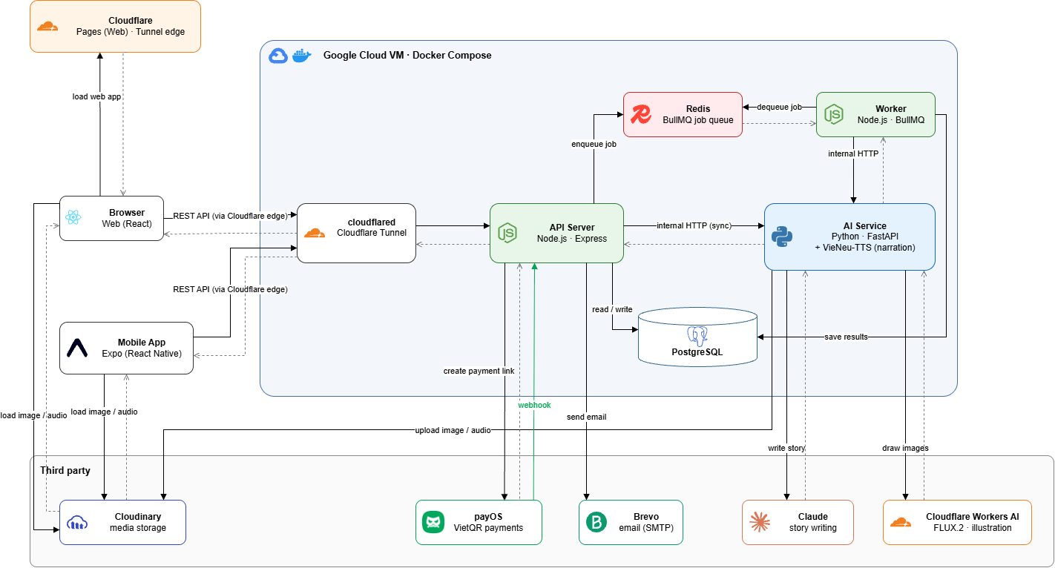
System Architecture Diagram

Component | Technology | Responsibility
Web application | React 19, Vite 8, React Router 7, TanStack Query 5, Zustand 5, Tailwind CSS 4 | Parent / Seller workspace, Kid Mode reader, Specialist and Admin portals; calls the REST API with JWT or kid session token.
REST API | Node.js 22, Express 5, Zod 4, Prisma 6, Swagger | Authentication, role-based access, business rules, commerce, ledger, payOS checkout and webhook; enqueues AI jobs.
Worker | Node.js 22, BullMQ 5, ioredis | AI workers (story text, portrait, scene image), narration worker (concurrency 1), cron every BILLING_CYCLE_MINUTES: billing cycle, earning release, random audits.
Queue | Redis | BullMQ job queues ai and narration with retries.
Database | PostgreSQL | All business data, append-only wallet ledger, partial unique constraints.
AI service | Python 3.12, FastAPI | Stateless; story generation (Claude via the claude_code provider – Claude Agent SDK; Anthropic API and Gemini API selectable by LLM_PROVIDER), TTS (VieNeu-TTS), images (Cloudflare Workers AI FLUX.2 klein); validates output, uploads media to Cloudinary. Does not read the database.
Media storage | Cloudinary (type=authenticated) | Portraits, scene images, narration MP3; the API returns signed URLs.
Payment | payOS (@payos/node) | VietQR payment links, webhook, order status.
Email | Brevo API / SMTP (nodemailer) | Verification and password recovery emails.

1.2 Package Diagram
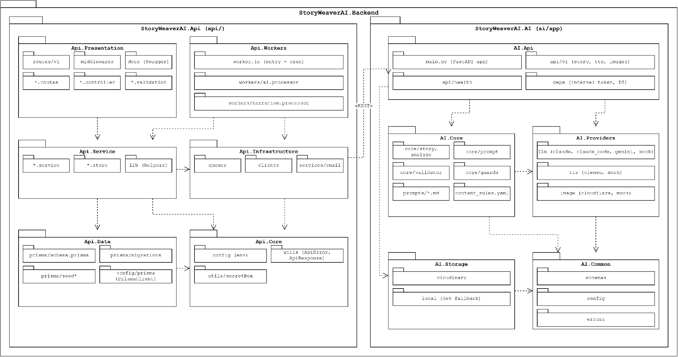

# | Package | Description
1 | api/src/routes/v1 | Mounts every module router under /api/v1.
2 | api/src/middlewares | JWT auth, role check, kidAuth for Kid Mode, Zod validate, error handler.
3 | api/src/modules/auth, children, characters | Account, tokens, Kid PIN and Kid Mode session, child profiles, family characters, EQ report endpoints. Also GET /children/:id/usage (reading time of a day, from the child's play sessions) and PUT /children/:id/avatar (sets the child's character appearance / portraitImageKey; kept for compatibility).
4 | api/src/modules/stories, bookshelf, kid | Story CRUD, editor, AI generation, narration, images; bookshelf; Kid Mode reading and scoring.
5 | api/src/modules/topics, sub-skills, question-templates, checkpoint-review, pedagogy-settings, content-library, keywords, eq-skills | Specialist pedagogical library and settings.
6 | api/src/modules/publishing, market, reviews, monitoring | Seller onboarding, listings and moderation, marketplace and withdrawals, reviews, reports / strikes / audits.
7 | api/src/modules/plans, billing, refunds, wallets, admin | Plans and subscriptions, payOS orders and billing cycle, refunds, credit / earning ledgers, Admin functions and finance.
8 | api/src/modules/*/lib | Pure business rule functions (no database) covered by unit tests.
9 | api/src/clients | aiClient (AI service HTTP), payos, assetUrl (Cloudinary signed URLs).
10 | api/src/queues, workers, worker.js | BullMQ queues, AI and narration processors, worker entry with cron.
11 | api/prisma | Prisma schema, migrations and seed scripts.
12 | ai/app/api/v1 | FastAPI routers: /v1/story, /v1/tts, /v1/images (internal token).
13 | ai/app/core, prompts | Prompt building, output validation, content rules.
14 | ai/app/providers | Pluggable providers: LLM (claude, claude_code, gemini, mock), tts (Vieneu, mock), image (cloudflare, mock).
15 | ai/app/storage | Cloudinary upload of generated media.

2. Database Design
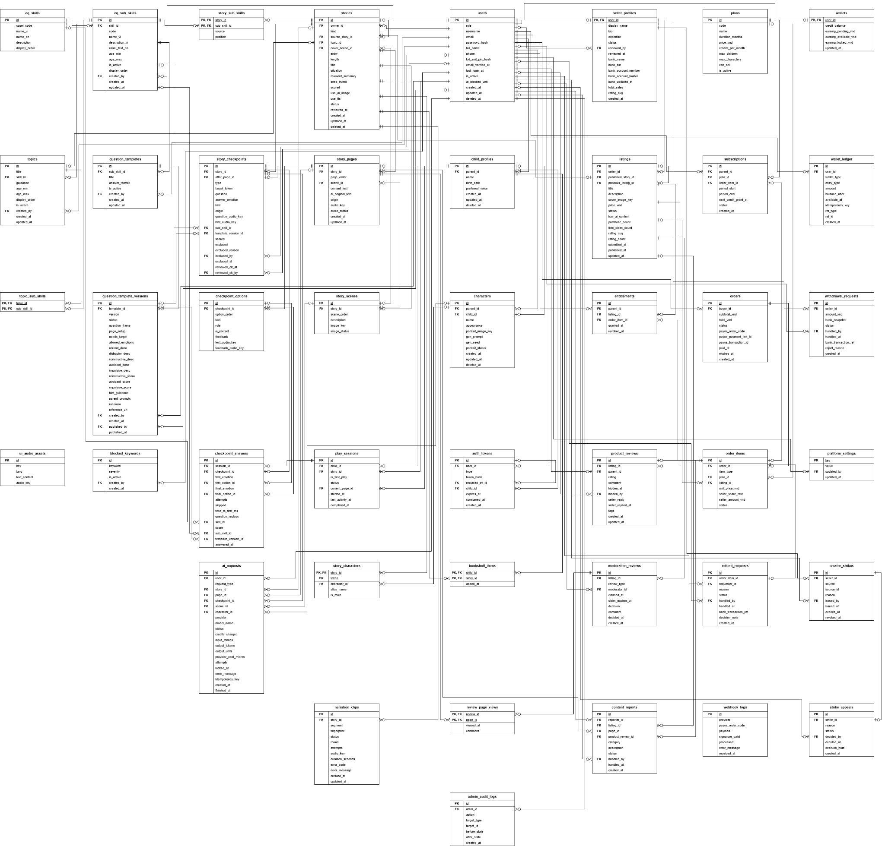

No | Table | Description
1 | users | Accounts of parents, specialists and admins: credentials, role, kid exit PIN hash, AI block until. Primary key: id. Foreign keys: None.
2 | auth_tokens | Hashed refresh, email verification, password reset and kid session tokens. Primary key: id. Foreign keys: user_id → users.id; replaced_by_id → auth_tokens.id; child_id → child_profiles.id.
3 | child_profiles | Children of a parent: name, birth date, preferred voice (appearance is kept on the representative character). Primary key: id. Foreign keys: parent_id → users.id.
4 | characters | Family characters with text-only appearance and optional AI portrait; at most one per child. Primary key: id. Foreign keys: parent_id → users.id; child_id → child_profiles.id.
5 | eq_skills | The five CASEL competencies. Primary key: id. Foreign keys: None.
6 | topics | Model stories (competency, age range, suggested plot) managed by specialists. Primary key: id. Foreign keys: skill_id → eq_skills.id; created_by → users.id.
7 | eq_sub_skills | Standard CASEL sub-skill catalogue (code, Vietnamese name and description, casel_text_en, age range, on / off); Specialists adjust but never add or delete. Primary key: id. Foreign keys: skill_id → eq_skills.id; created_by → users.id.
8 | question_templates | Question template identity per sub-skill. Primary key: id. Foreign keys: sub_skill_id → eq_sub_skills.id; created_by → users.id.
9 | question_template_versions | Draft / published versions with question, options and scores. Primary key: id. Foreign keys: template_id → question_templates.id; created_by → users.id; published_by → users.id.
10 | topic_sub_skills | Link of a topic to its 1–3 sub-skills. Primary key: topic_id, sub_skill_id. Foreign keys: topic_id → topics.id; sub_skill_id → eq_sub_skills.id.
11 | ui_audio_assets | Shared UI audio (emotion names, prompts) for Kid Mode. Primary key: id. Foreign keys: None.
12 | blocked_keywords | Blocked / warning keywords. Primary key: id. Foreign keys: created_by → users.id.
13 | stories | Private stories and published copies: entry (topic / family / handwritten), length, status, situation, moment summary, seed event, scored, cover scene, review time. Primary key: id. Foreign keys: owner_id → users.id; source_story_id → stories.id; topic_id → topics.id; cover_scene_id → story_scenes.id.
14 | story_sub_skills | 1–2 sub-skills practised by a family story (position 1 = main; source moment / need / parent). Primary key: story_id, sub_skill_id. Foreign keys: story_id → stories.id; sub_skill_id → eq_sub_skills.id.
15 | story_characters | Characters of a story with {NVx} token; character_id for private, alias_name for published. Primary key: story_id, token. Foreign keys: story_id → stories.id; character_id → characters.id.
16 | story_scenes | Up to 4 scenes per story with image status and key; one of them is the cover. Primary key: id. Foreign keys: story_id → stories.id.
17 | story_pages | Pages with tokenized text and content origin. Primary key: id. Foreign keys: story_id → stories.id; scene_id → story_scenes.id.
18 | story_checkpoints | Checkpoints after a page: type, sub-skill, template version, scored / excluded flags. Primary key: id. Foreign keys: story_id → stories.id; after_page_id → story_pages.id; sub_skill_id → eq_sub_skills.id; template_version_id → question_template_versions.id; excluded_by → users.id; reviewed_ok_by → users.id.
19 | checkpoint_options | Options of a checkpoint (role, correct flag). Primary key: id. Foreign keys: checkpoint_id → story_checkpoints.id.
20 | narration_clips | Narration segments with fingerprint, audio key and status. Primary key: id. Foreign keys: story_id → stories.id.
21 | bookshelf_items | Stories assigned to a child’s bookshelf. Primary key: child_id, story_id. Foreign keys: child_id → child_profiles.id; story_id → stories.id.
22 | play_sessions | Reading sessions of a child (first play flag, progress, status). Primary key: id. Foreign keys: child_id → child_profiles.id; story_id → stories.id; current_page_id → story_pages.id.
23 | checkpoint_answers | Answers with first / final choice and snapshot of score, skill, sub-skill, template version. Primary key: id. Foreign keys: session_id → play_sessions.id; checkpoint_id → story_checkpoints.id; first_option_id → checkpoint_options.id; final_option_id → checkpoint_options.id; skill_id → eq_skills.id; sub_skill_id → eq_sub_skills.id; template_version_id → question_template_versions.id.
24 | ai_requests | Every AI call: type, status, credits charged, idempotency key, error. Primary key: id. Foreign keys: user_id → users.id; story_id → stories.id; page_id → story_pages.id; checkpoint_id → story_checkpoints.id; scene_id → story_scenes.id; character_id → characters.id.
25 | seller_profiles | Seller application and profile, bank account, status, totals. Primary key: user_id. Foreign keys: user_id → users.id; reviewed_by → users.id.
26 | listings | Published stories for sale: status, seller price (price_vnd), counters, cover image key. Primary key: id. Foreign keys: seller_id → seller_profiles.user_id; published_story_id → stories.id; previous_listing_id → listings.id.
27 | entitlements | Right of a parent to read a listing (revocable). Primary key: id. Foreign keys: parent_id → users.id; listing_id → listings.id; order_item_id → order_items.id.
28 | product_reviews | Ratings, comments and tags of buyers, one seller reply, hidden flag. Primary key: id. Foreign keys: listing_id → listings.id; parent_id → users.id; hidden_by → users.id.
29 | plans | Subscription plans: price, duration, credits per month, limits, can sell. Primary key: id. Foreign keys: None.
30 | subscriptions | Plan periods of a parent with next credit grant time. Primary key: id. Foreign keys: parent_id → users.id; plan_id → plans.id; order_item_id → order_items.id.
31 | orders | Payment orders (payOS order code, status, expiry). Primary key: id. Foreign keys: buyer_id → users.id.
32 | order_items | Plan or listing item with price and seller share snapshot. Primary key: id. Foreign keys: order_id → orders.id; plan_id → plans.id; listing_id → listings.id.
33 | refund_requests | Refund requests and admin decisions. Primary key: id. Foreign keys: order_item_id → order_items.id; requester_id → users.id; handled_by → users.id.
34 | webhook_logs | Raw payOS webhook calls with signature result. Primary key: id. Foreign keys: None.
35 | wallets | Credit and earning balances of a user. Primary key: user_id. Foreign keys: user_id → users.id.
36 | wallet_ledger | Append-only ledger of all balance changes. Primary key: id. Foreign keys: user_id → users.id.
37 | withdrawal_requests | Seller withdrawals and payout references. Primary key: id. Foreign keys: seller_id → seller_profiles.user_id; handled_by → users.id.
38 | platform_settings | Key / value settings editable by Admin. Primary key: key. Foreign keys: updated_by → users.id.
39 | moderation_reviews | Submission, follow-up and random audit reviews. Primary key: id. Foreign keys: listing_id → listings.id; moderator_id → users.id.
40 | review_page_views | Pages viewed by the specialist during a review. Primary key: review_id, page_id. Foreign keys: review_id → moderation_reviews.id; page_id → story_pages.id.
41 | content_reports | Reports on listings or reviews. Primary key: id. Foreign keys: reporter_id → users.id; listing_id → listings.id; page_id → story_pages.id; product_review_id → product_reviews.id; handled_by → users.id.
42 | creator_strikes | Strikes issued to sellers with expiry. Primary key: id. Foreign keys: seller_id → seller_profiles.user_id; issued_by → users.id.
43 | strike_appeals | Appeals against strikes. Primary key: id. Foreign keys: strike_id → creator_strikes.id; decided_by → users.id.
44 | admin_audit_logs | Audit trail of Admin / Specialist actions. Primary key: id. Foreign keys: actor_id → users.id.

3. Detailed Design

3.1 Authentication & Authorization

3.1.1 Class Diagram
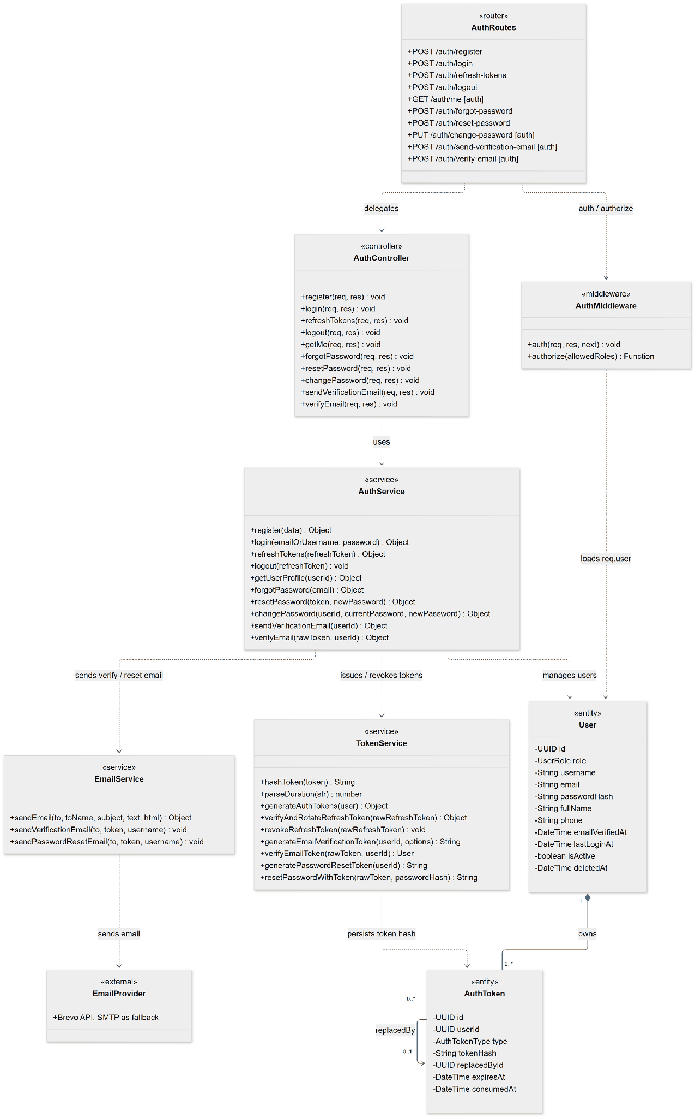

3.1.2 Sequence Diagram – Register An Account
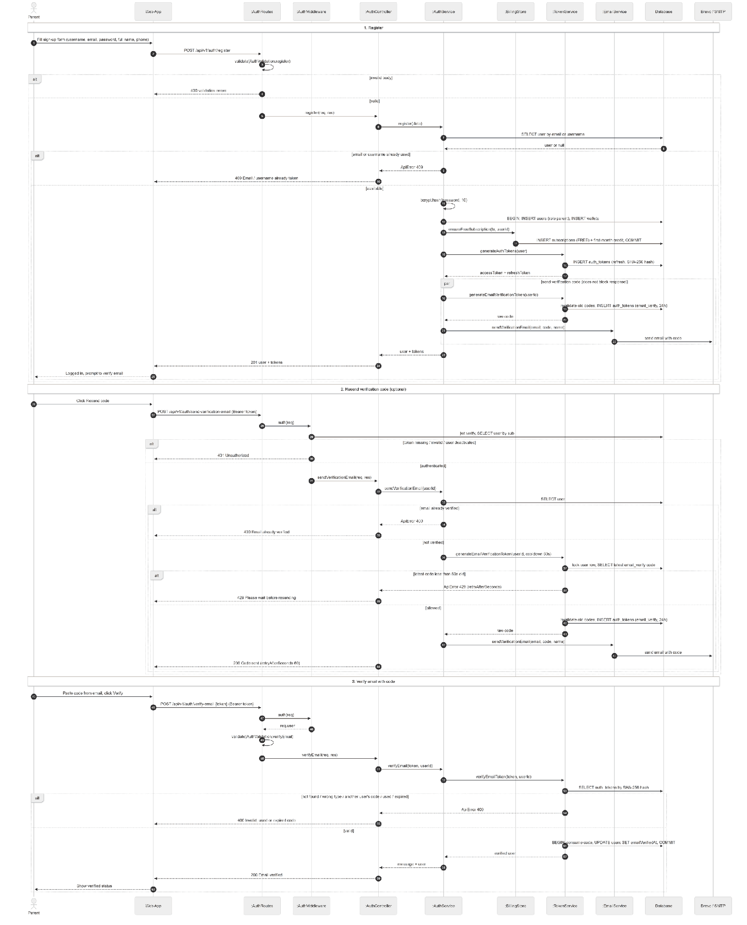

3.1.3 Sequence Diagram – Login And Manage Password
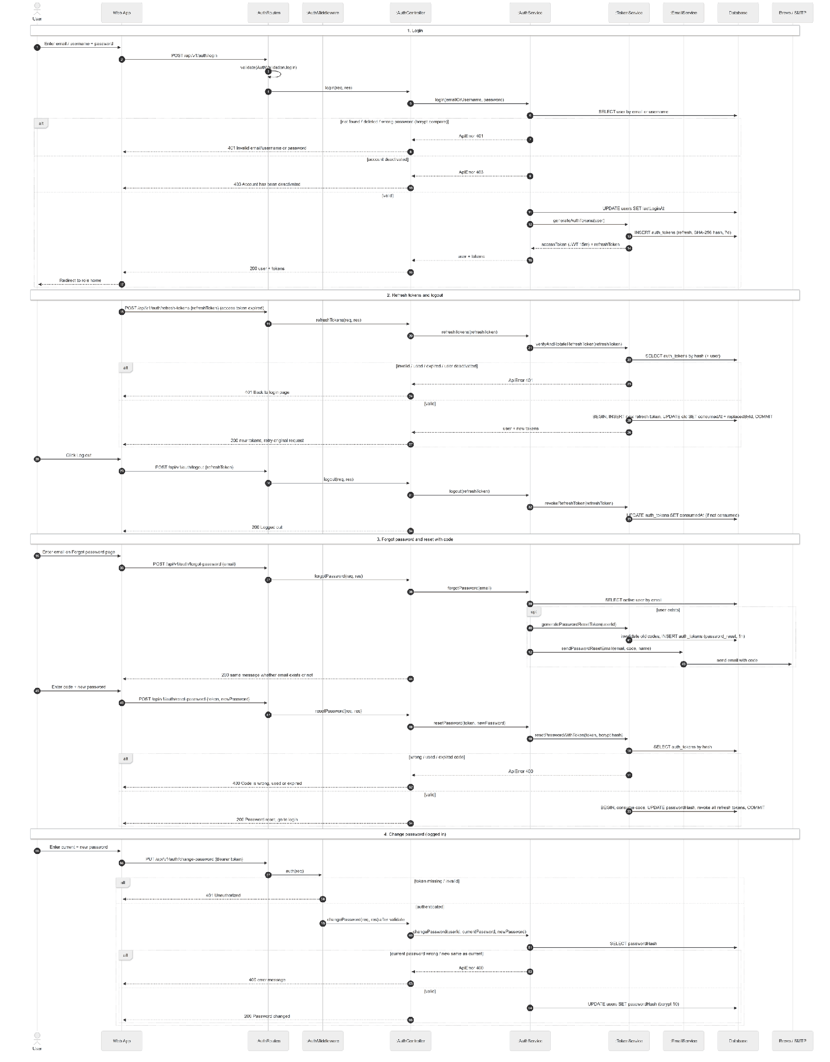

3.1.4 State Diagram
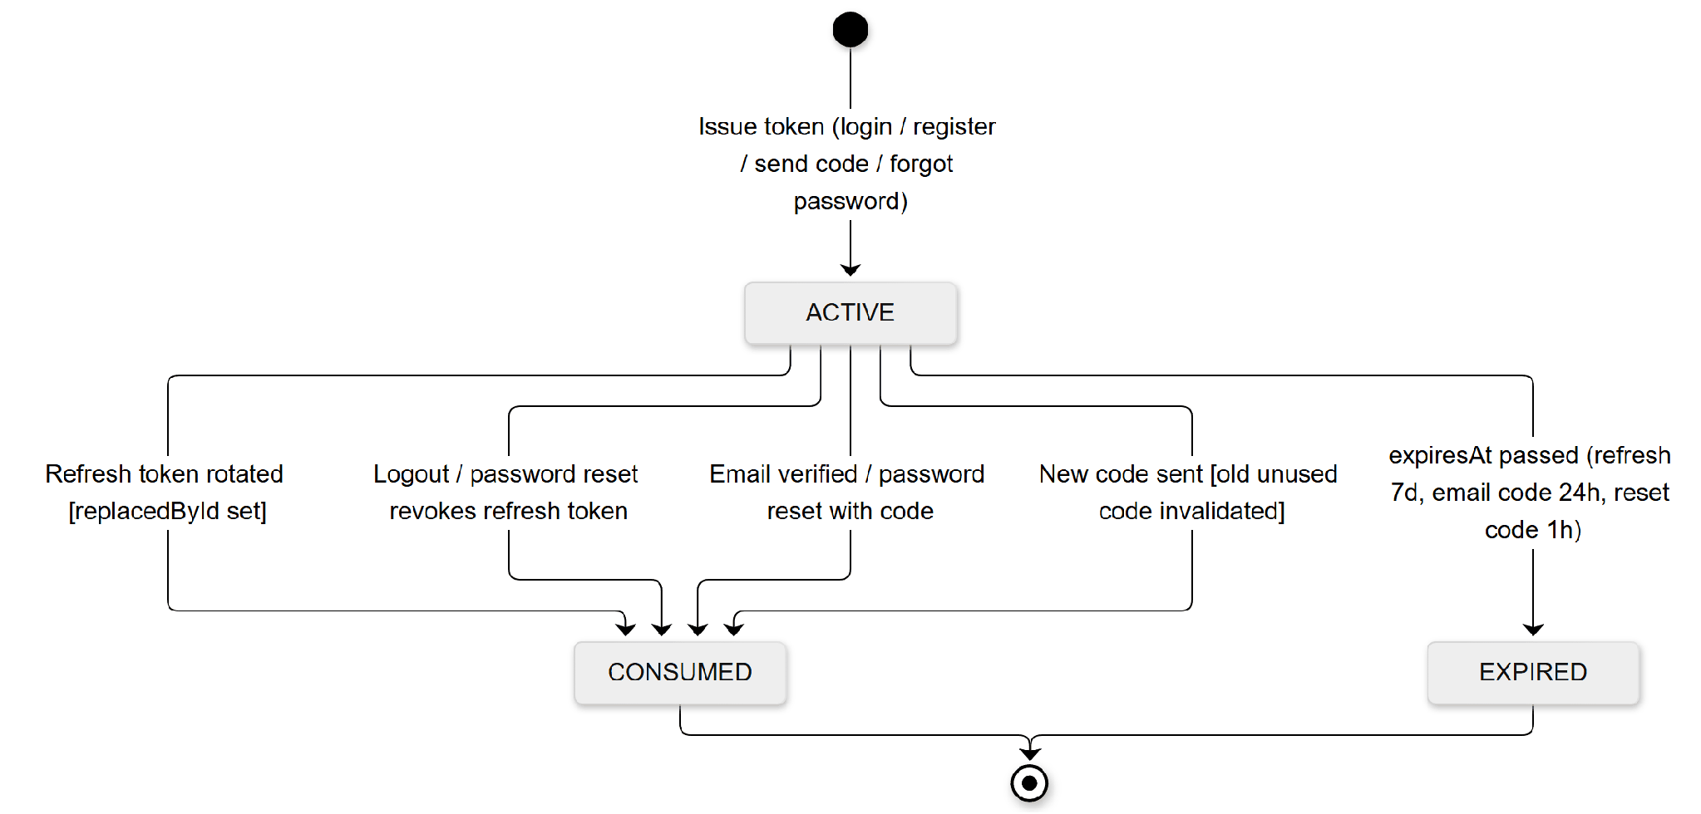

3.2 Create Story and Editing

3.2.1 Class Diagram
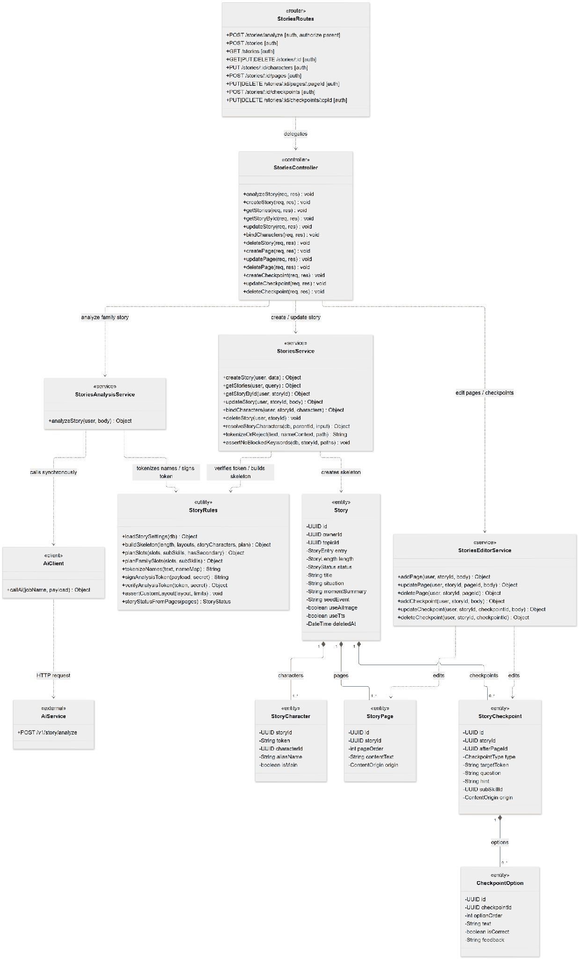

3.2.2 Sequence Diagram - Create And Edit A Story
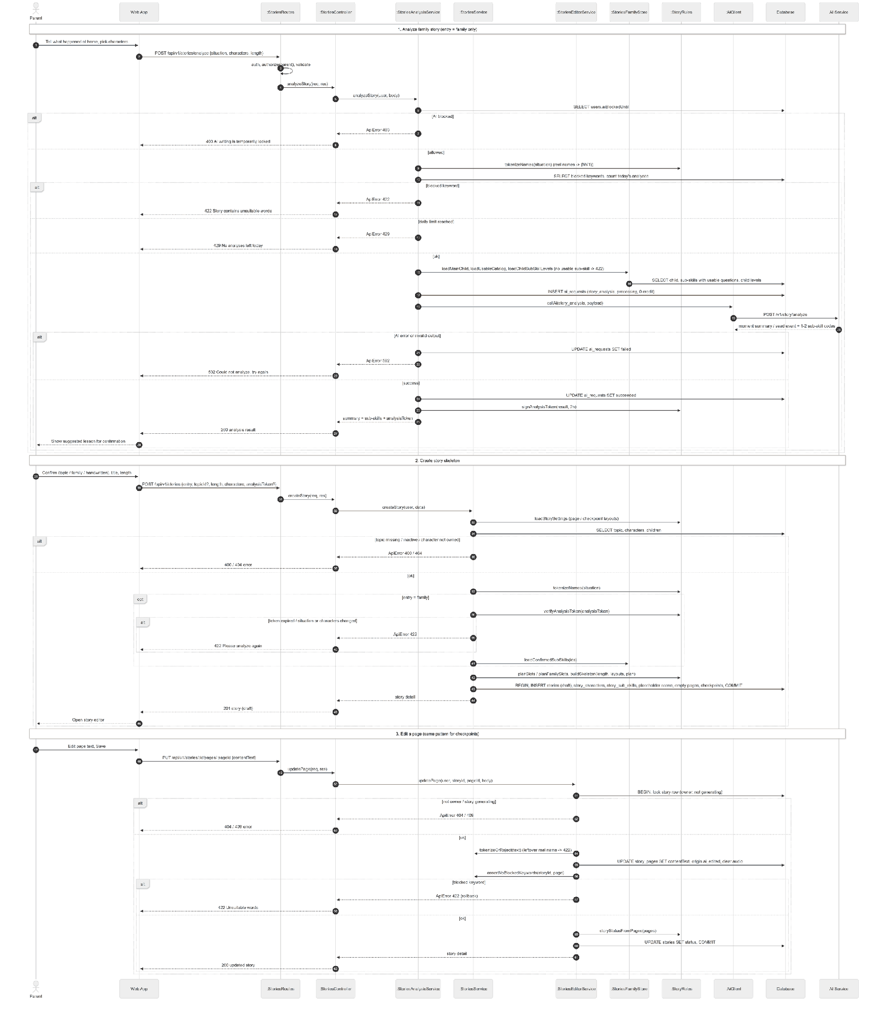

3.2.3 State Diagram
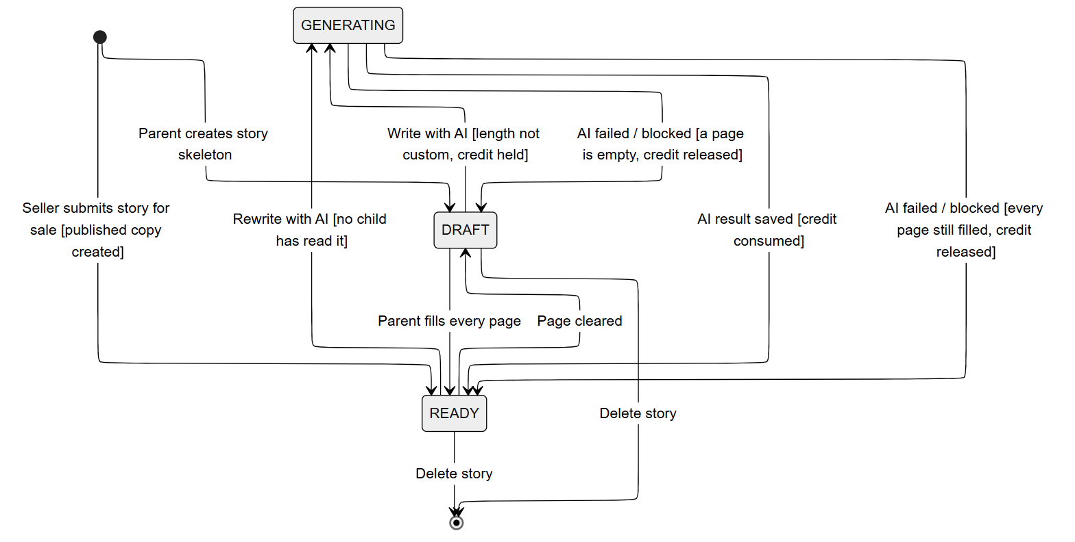
3.3 AI Text Generation

3.3.1 Class Diagram
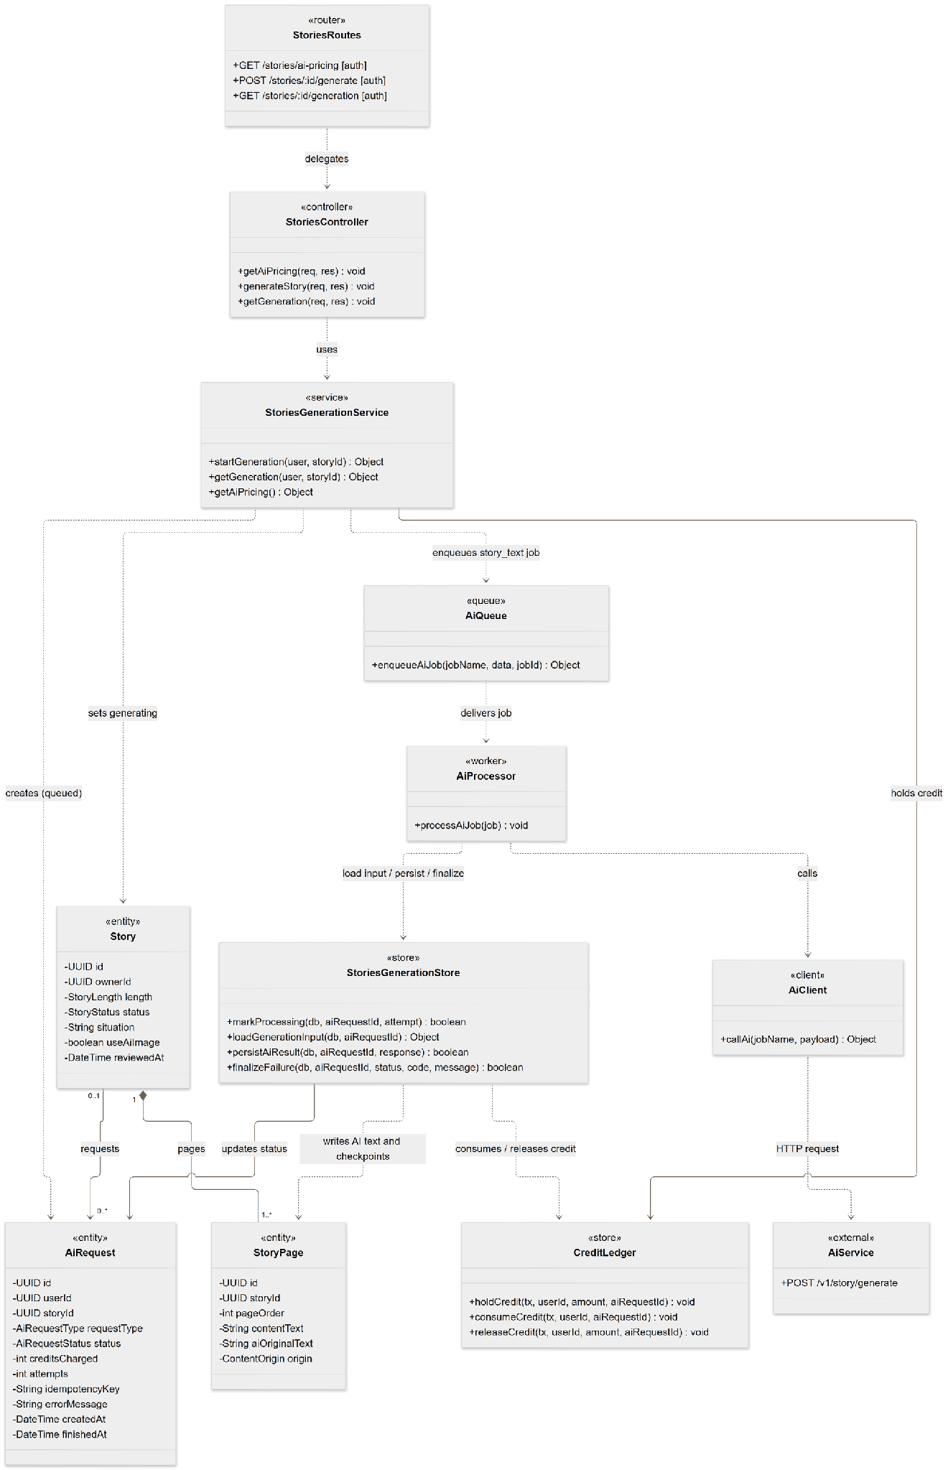

3.3.2 Sequence Diagram - Write A Story With AI
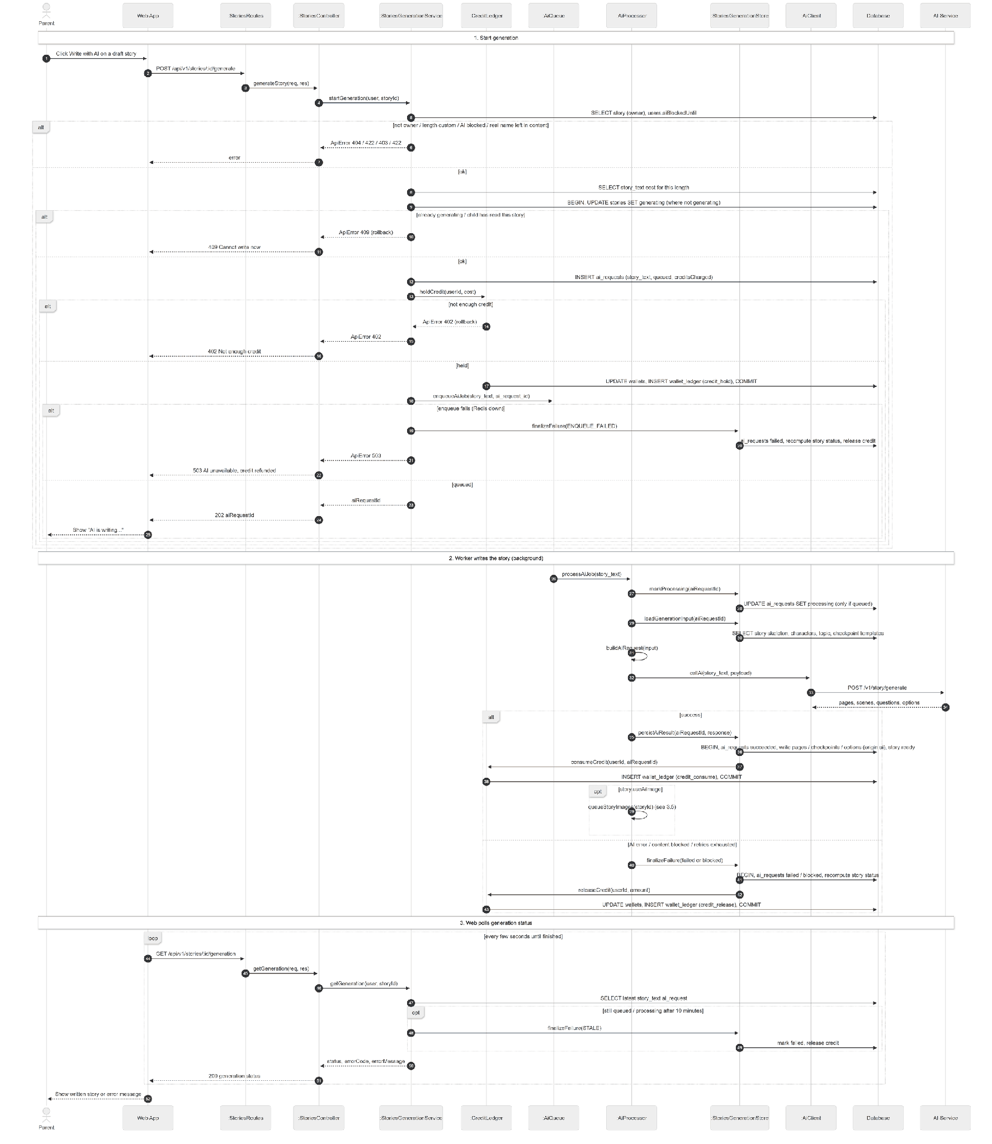

3.3.3 State Diagram
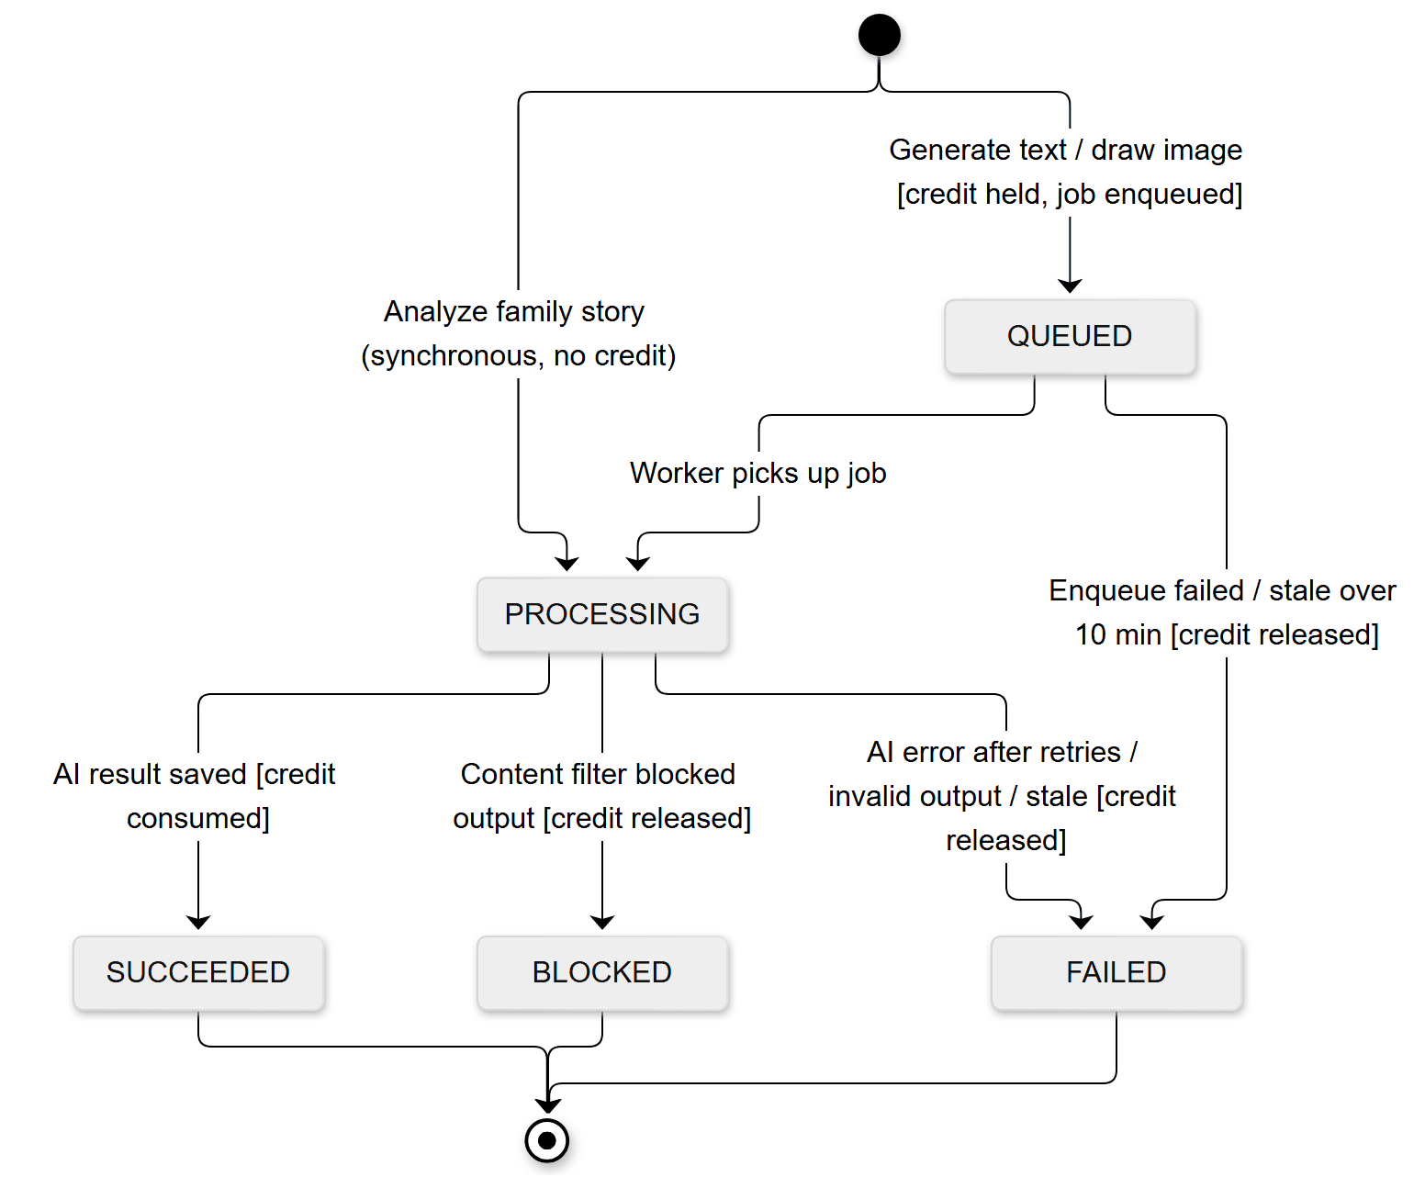

3.4 Story Review & Narration

3.4.1 Class Diagram
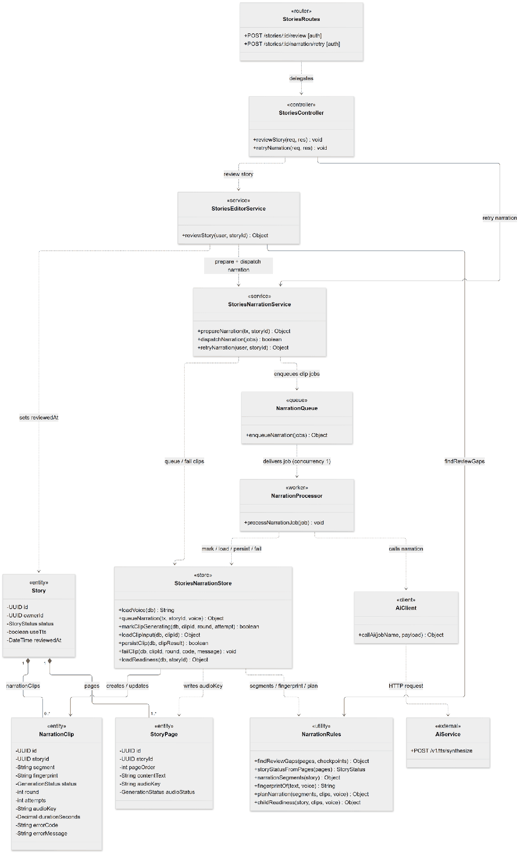

3.4.2 Sequence Diagram - Review Story And Generate Narration
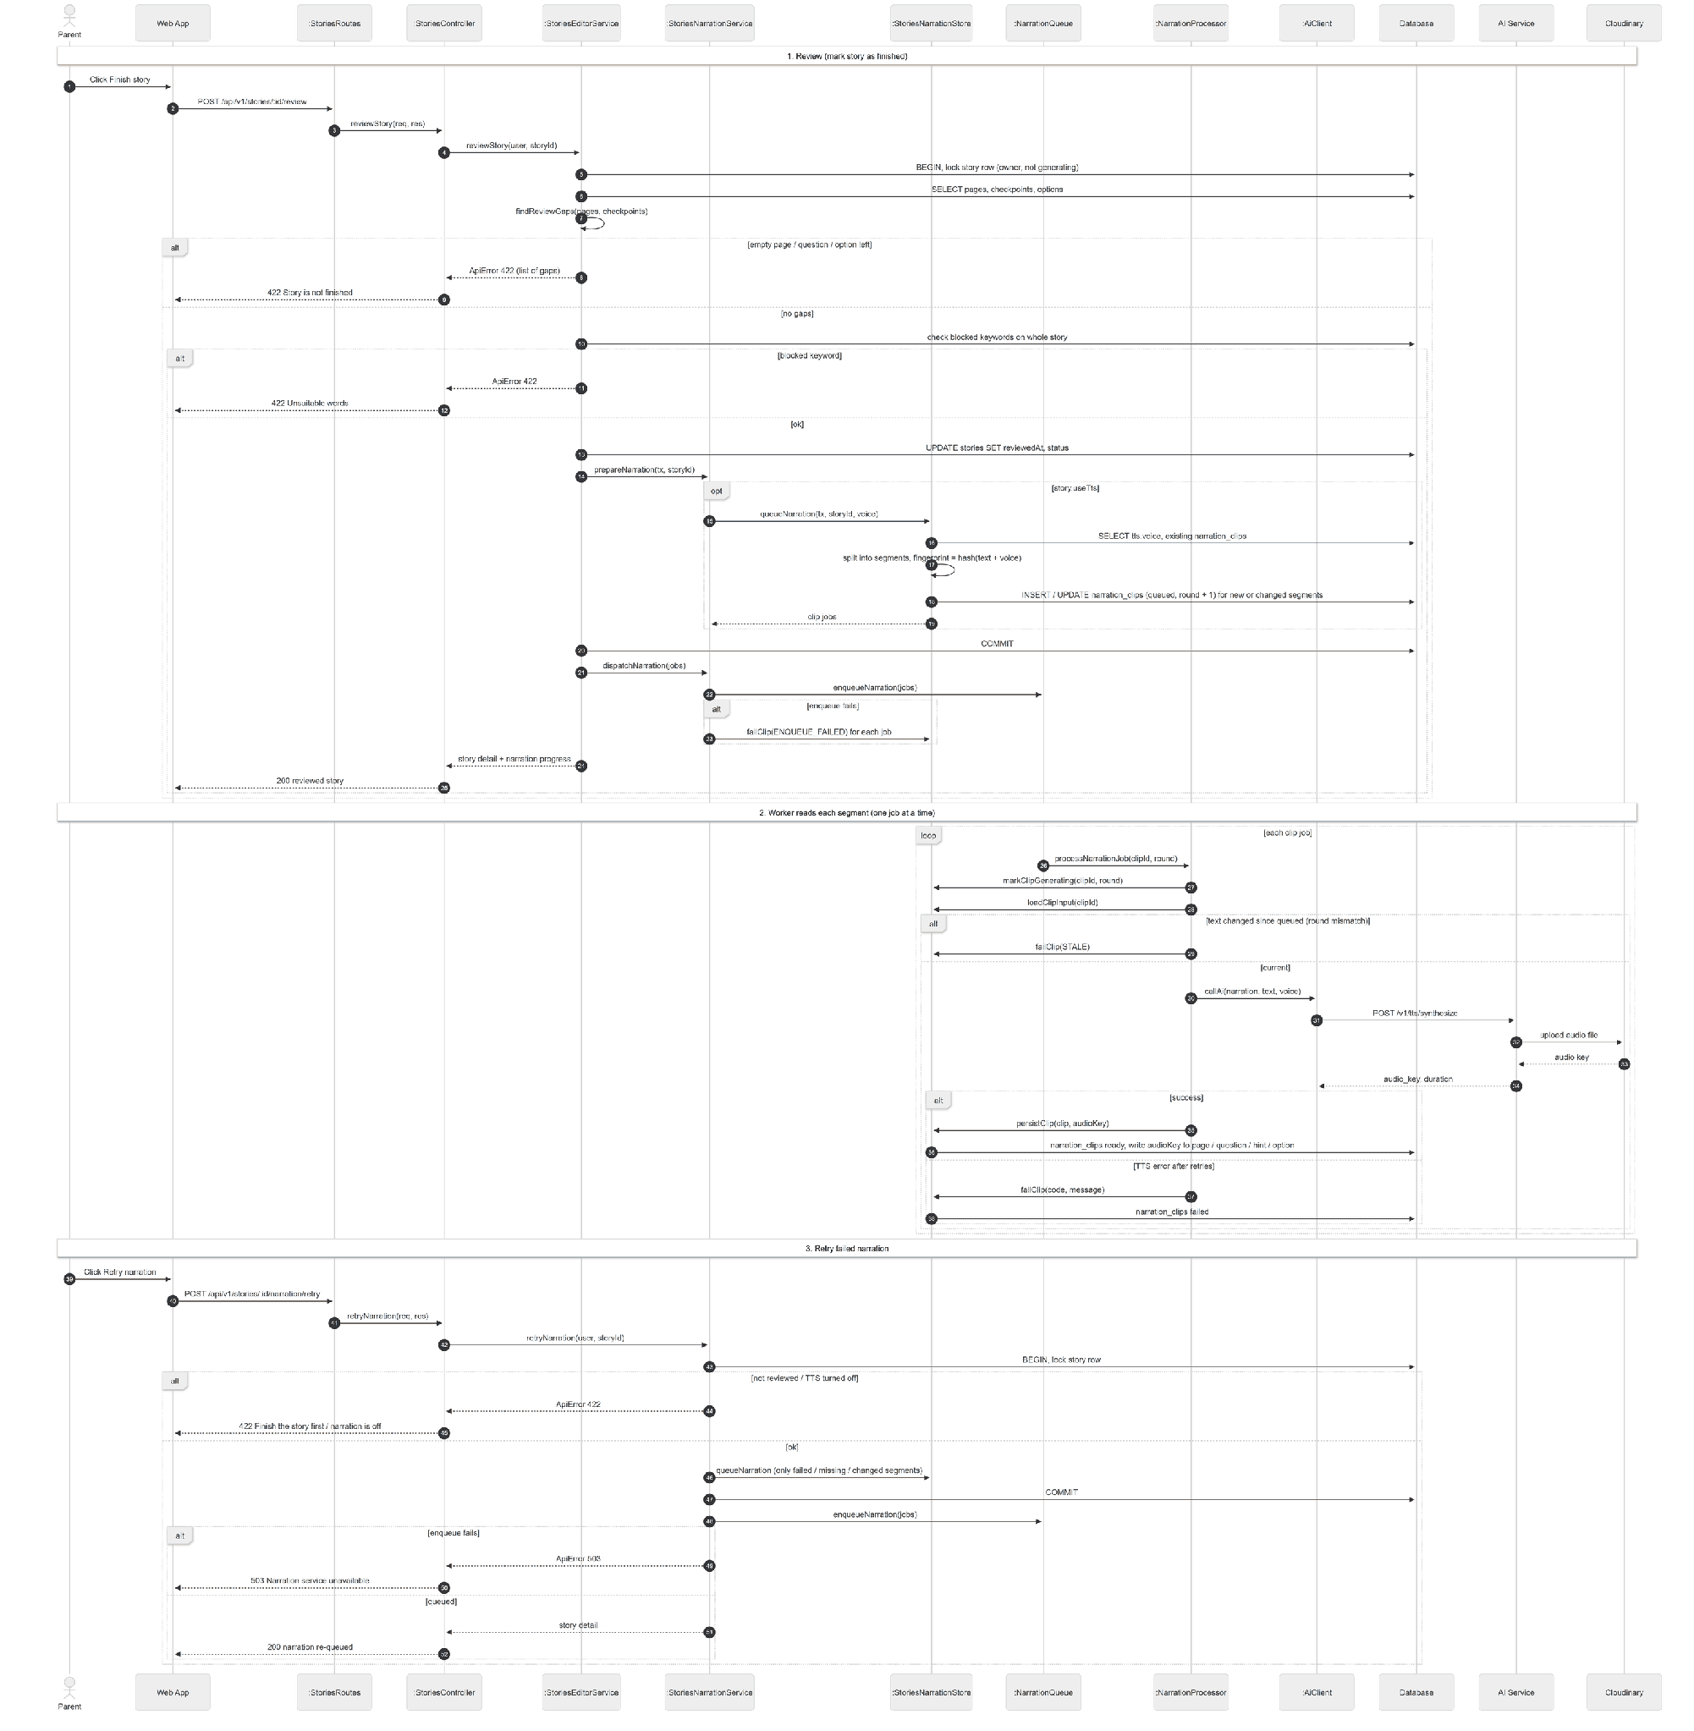

3.4.3 State Diagram

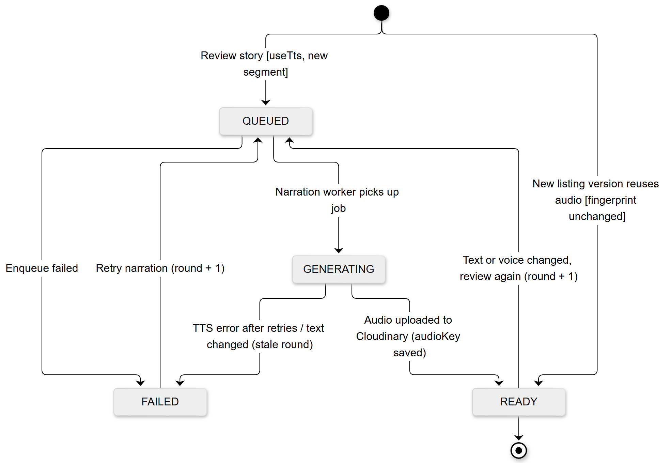

3.5 AI Illustration

3.5.1 Class Diagram
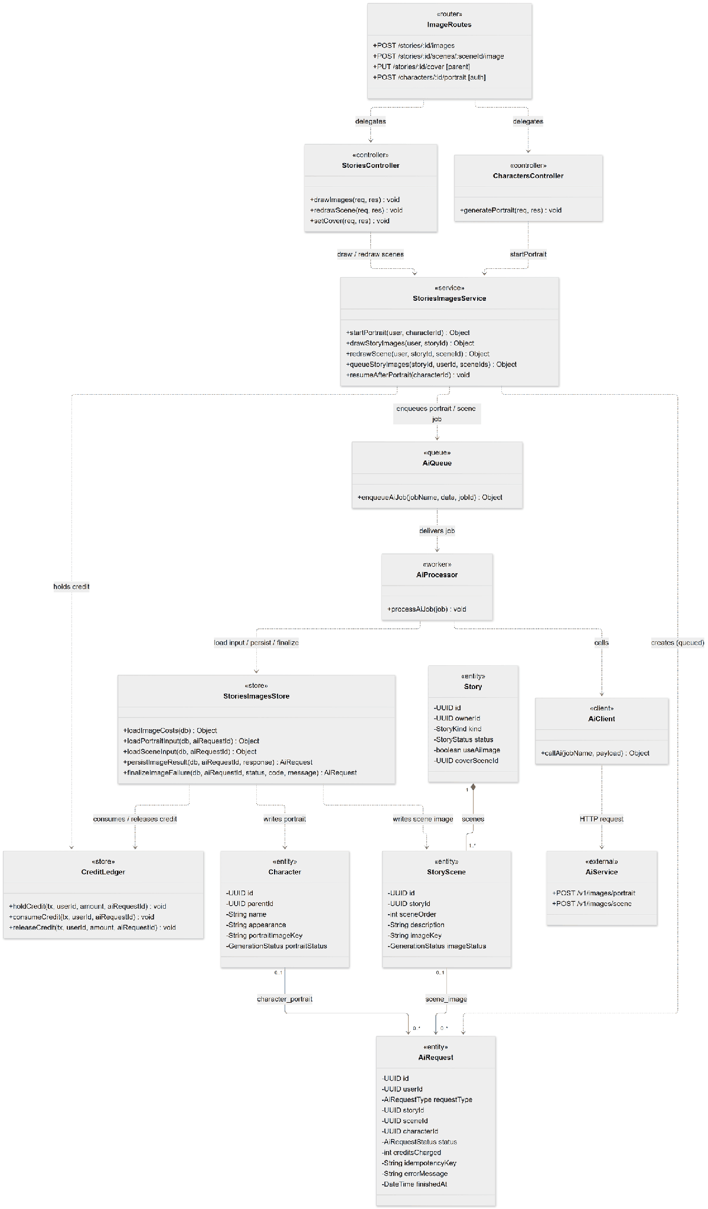

3.5.2 Sequence Diagram - Draw Story Illustrations

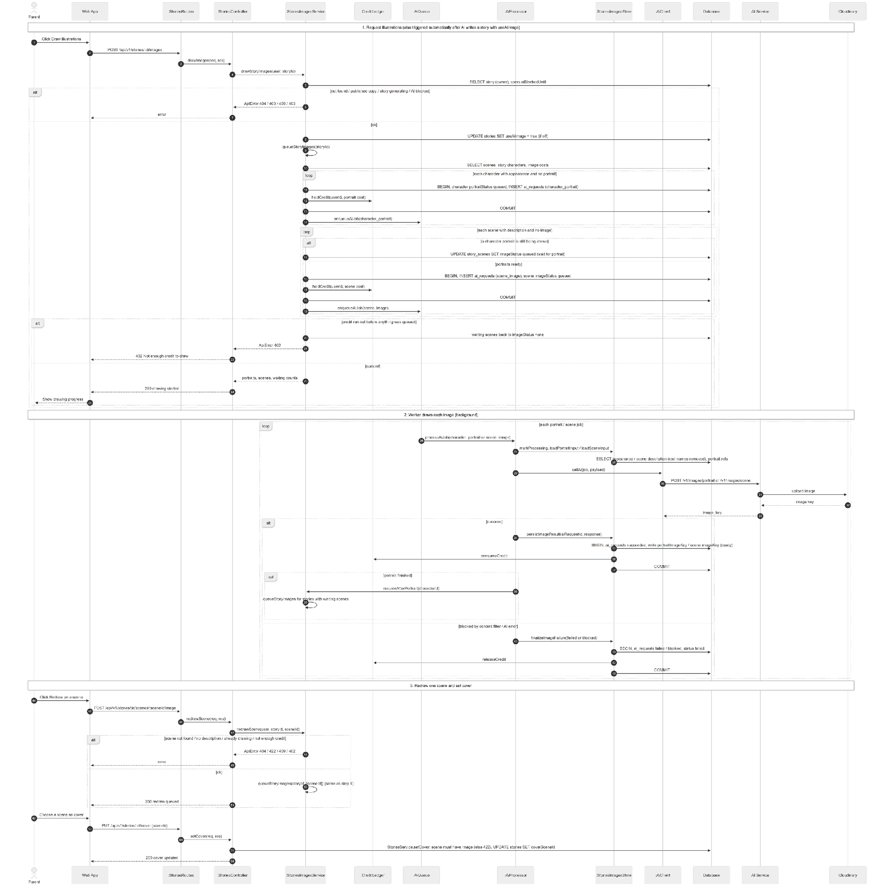

3.5.3 State Diagram
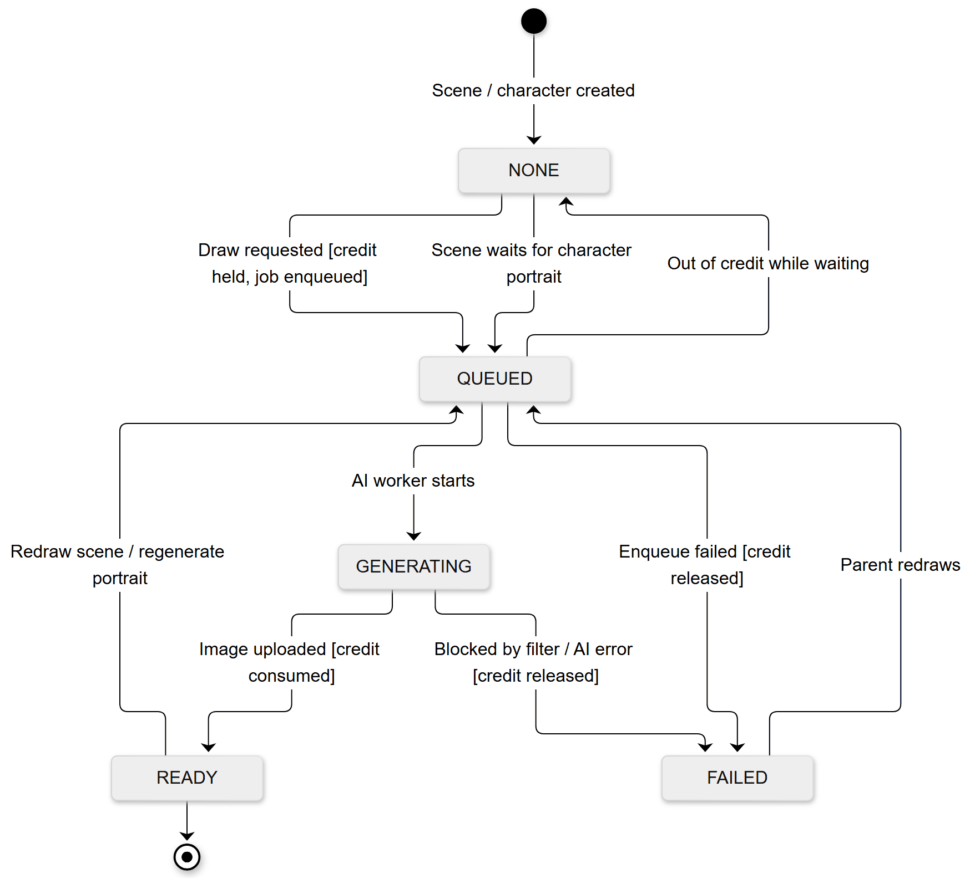

3.6 Seller Onboarding, Publishing and Moderation

3.6.1 Class Diagram
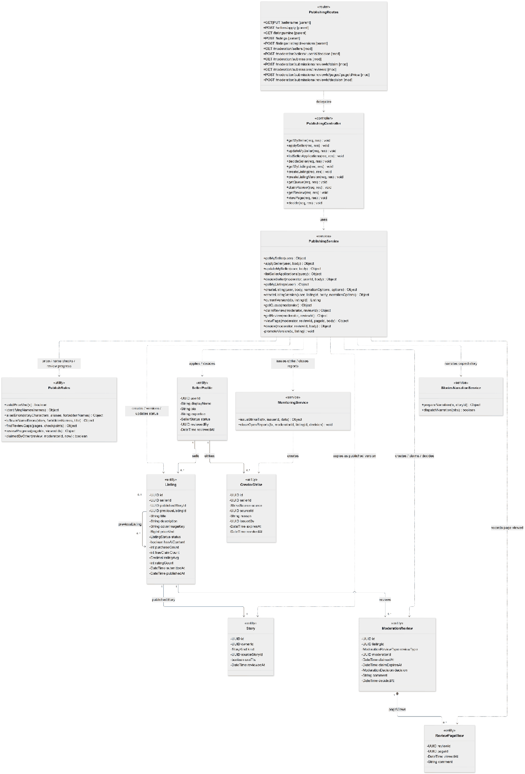

3.6.2 Sequence Diagram - Become A Seller And Publish A Story
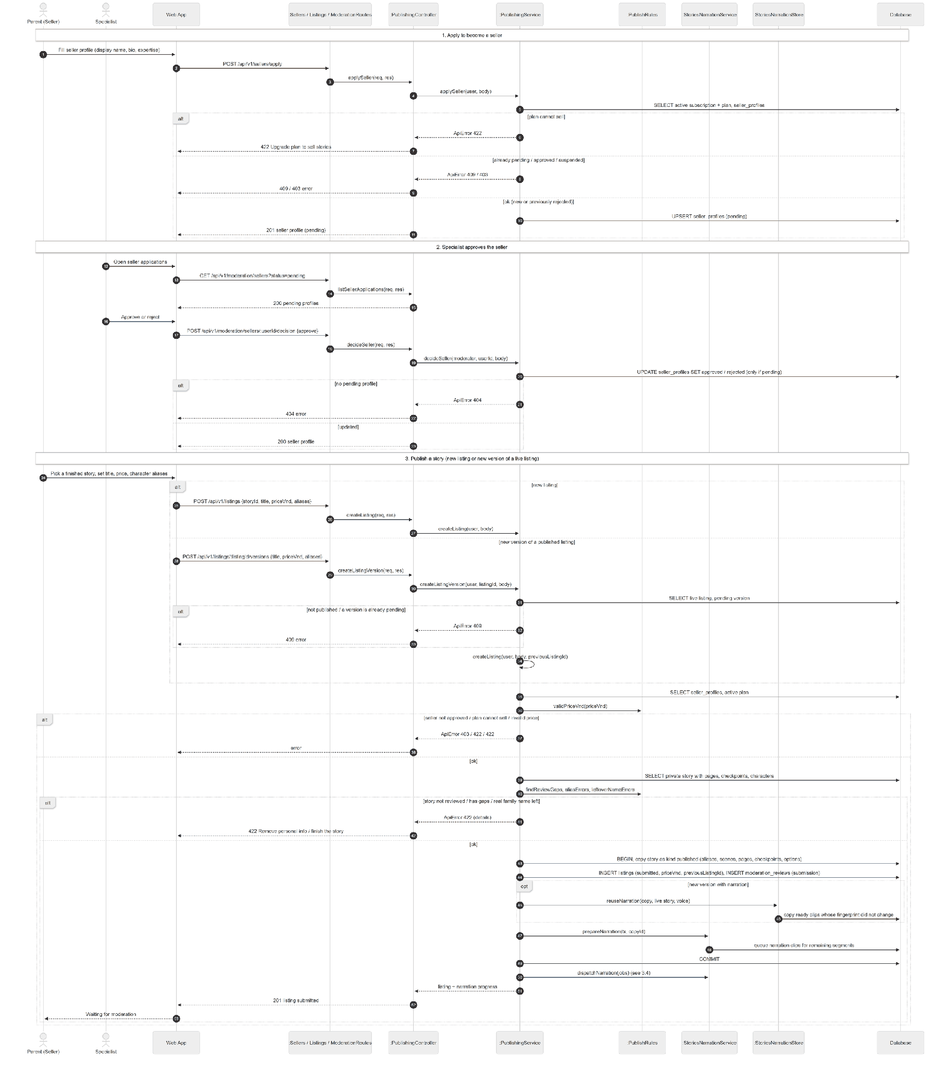

3.6.3 Sequence Diagram - Moderate A Story Submission

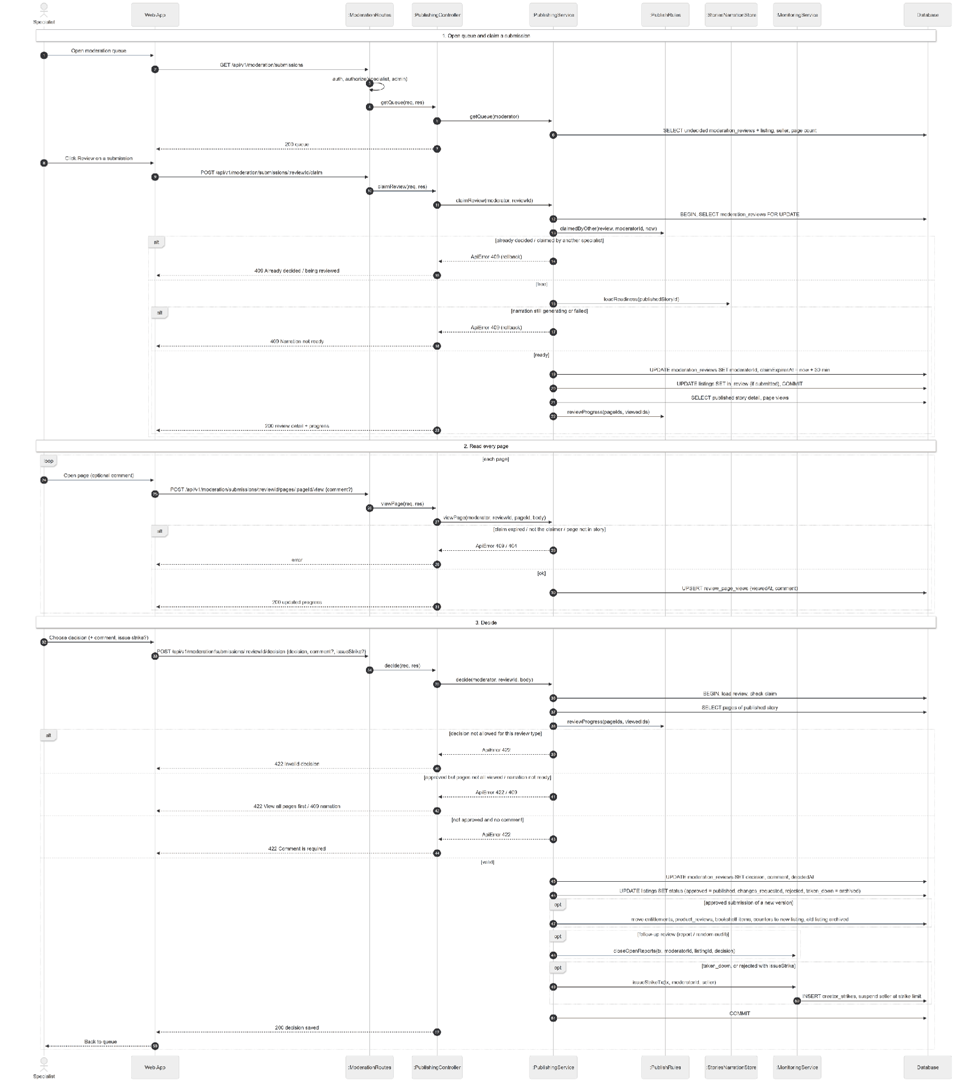

3.6.4 State Diagram - Seller Profile
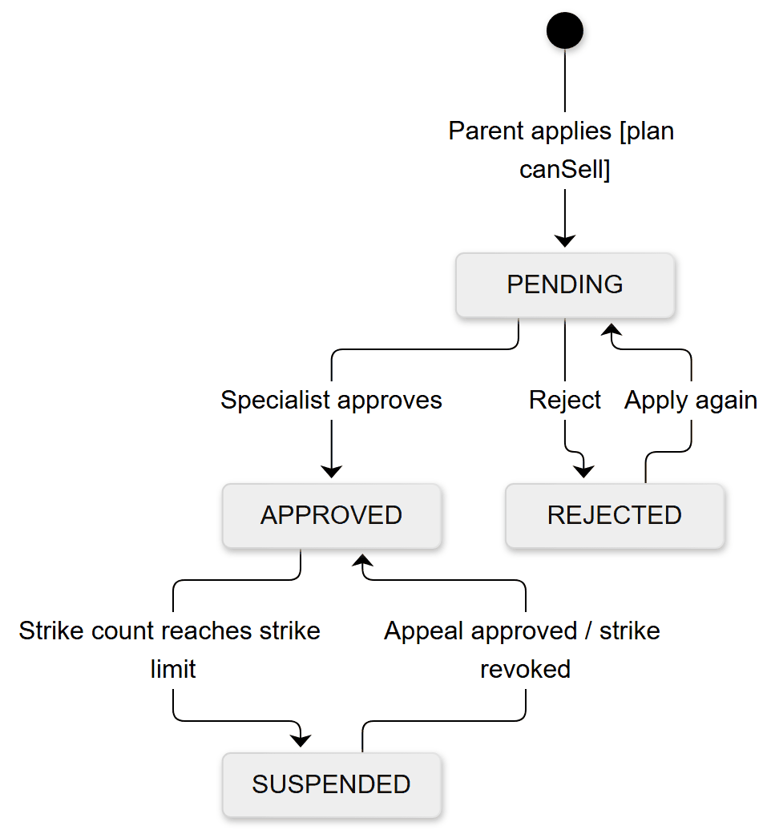

3.6.5 State Diagram - Listing
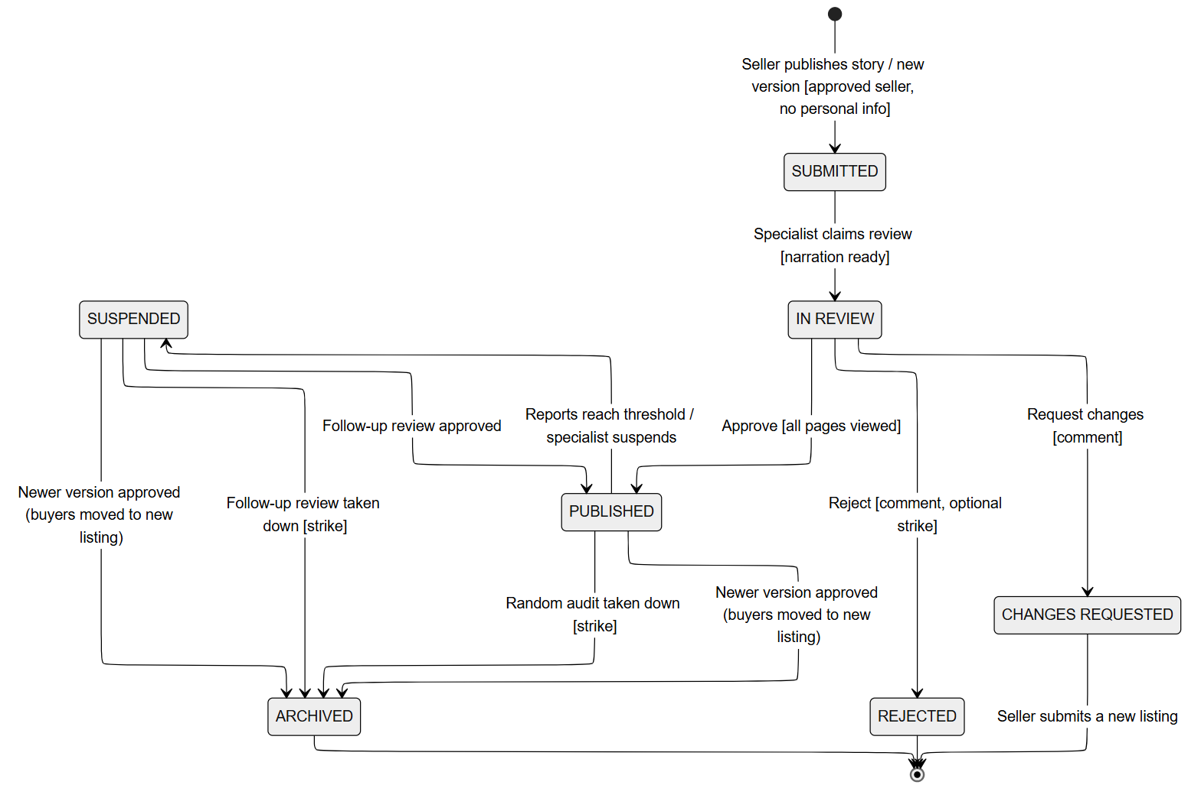

3.7 Subscription and payOS Payment

3.7.1 Class Diagram
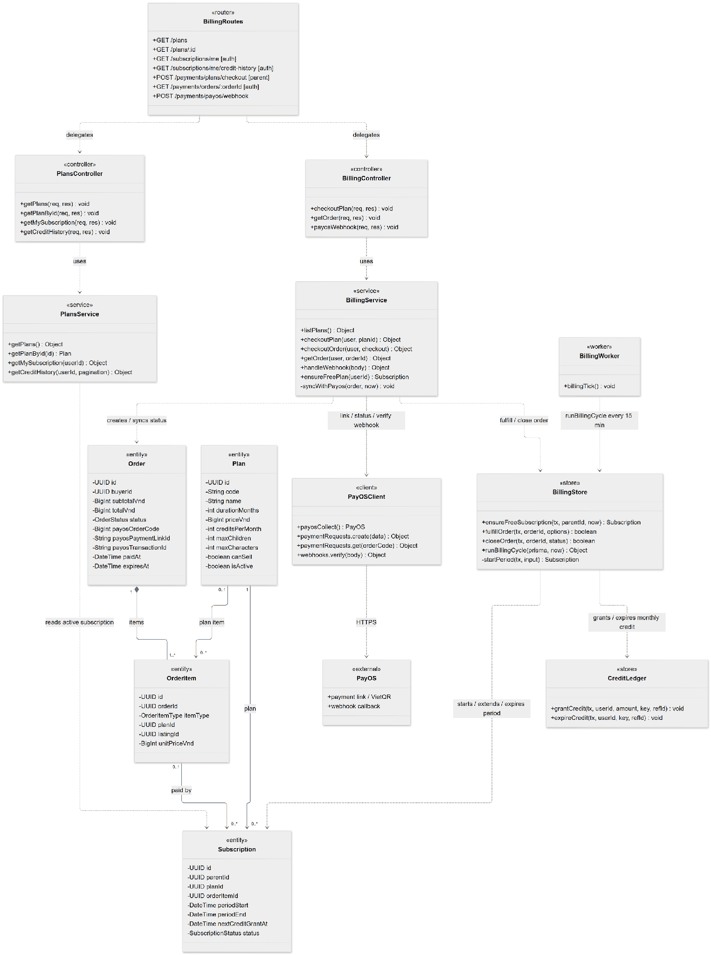

3.7.2 Sequence Diagram - Subscribe to a Plan
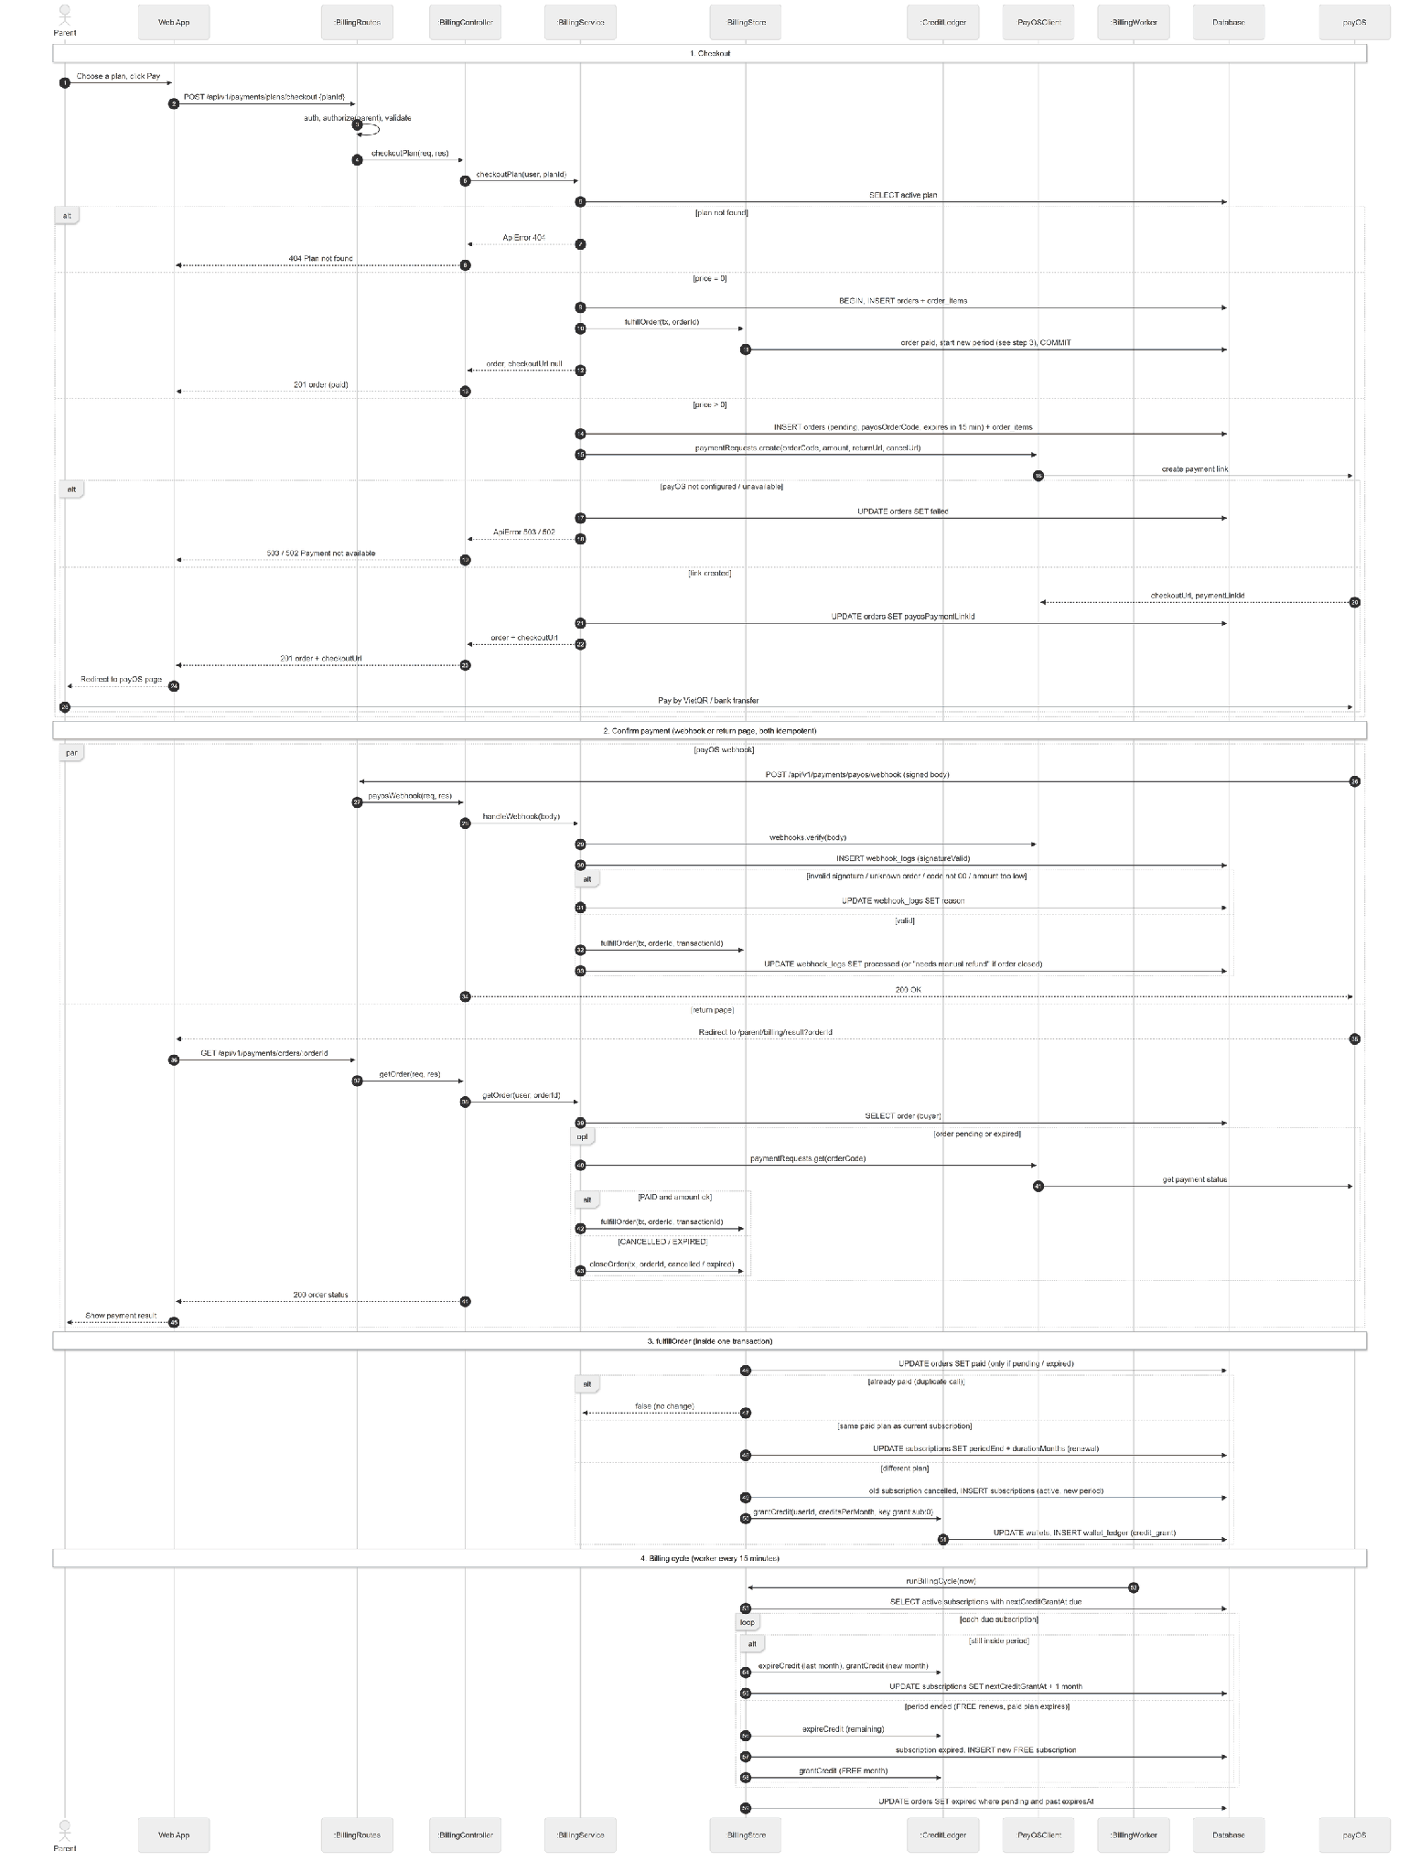

3.7.3 State Diagram - Order
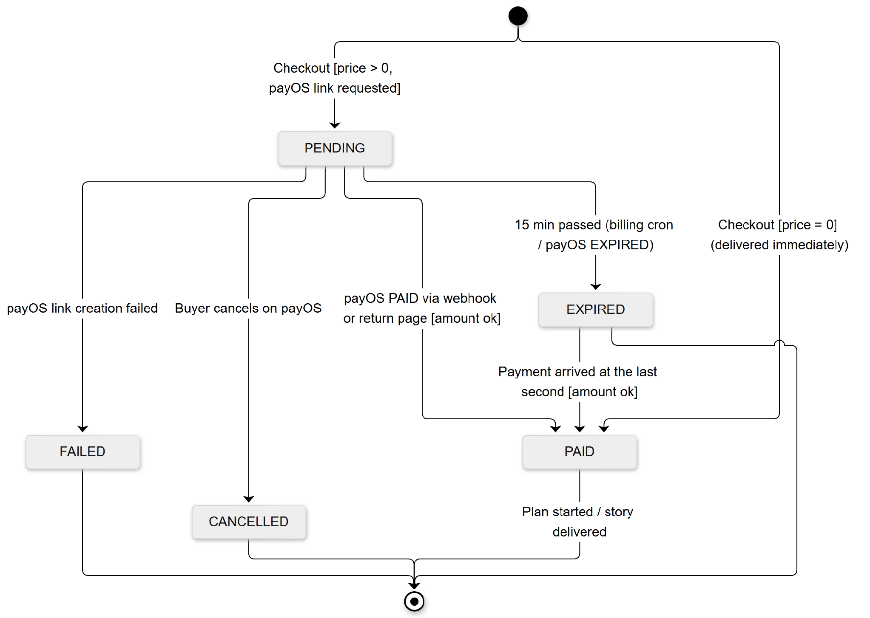

3.7.4 State Diagram - Subscription
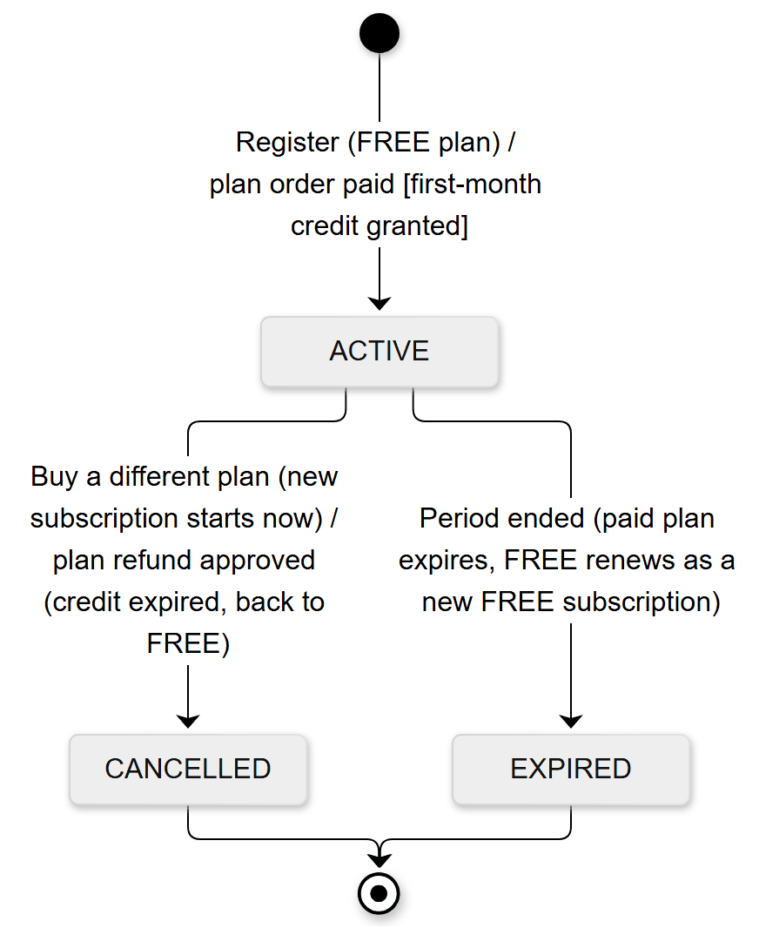

3.8 Marketplace Purchase & Seller Earnings

3.8.1 Class Diagram
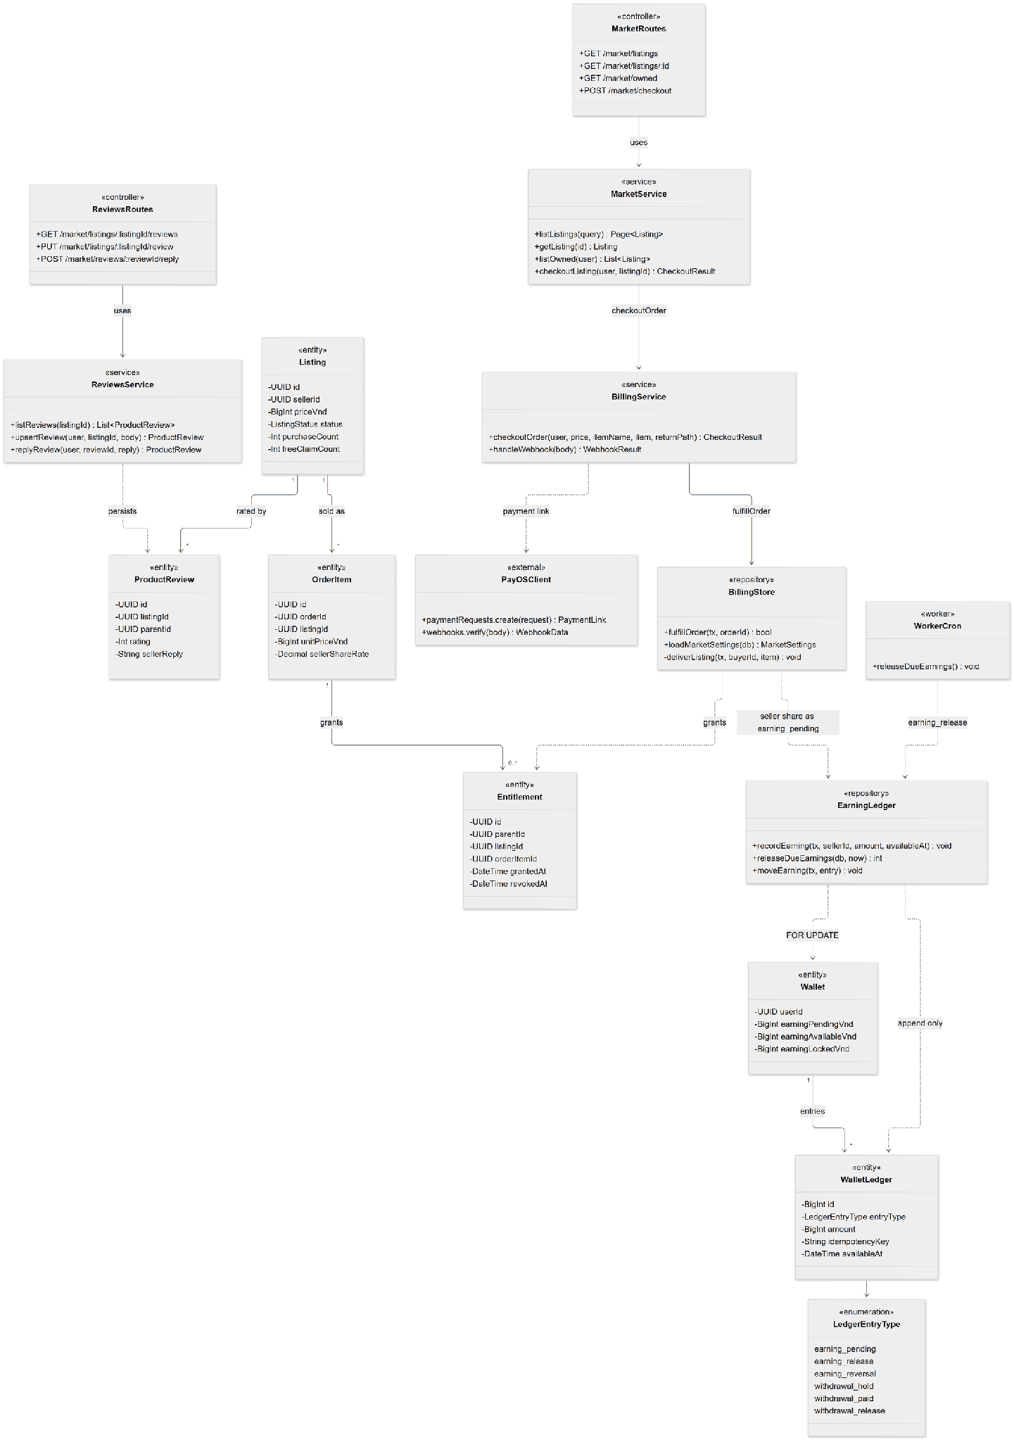

3.8.2 Sequence Diagram - Buy a Story
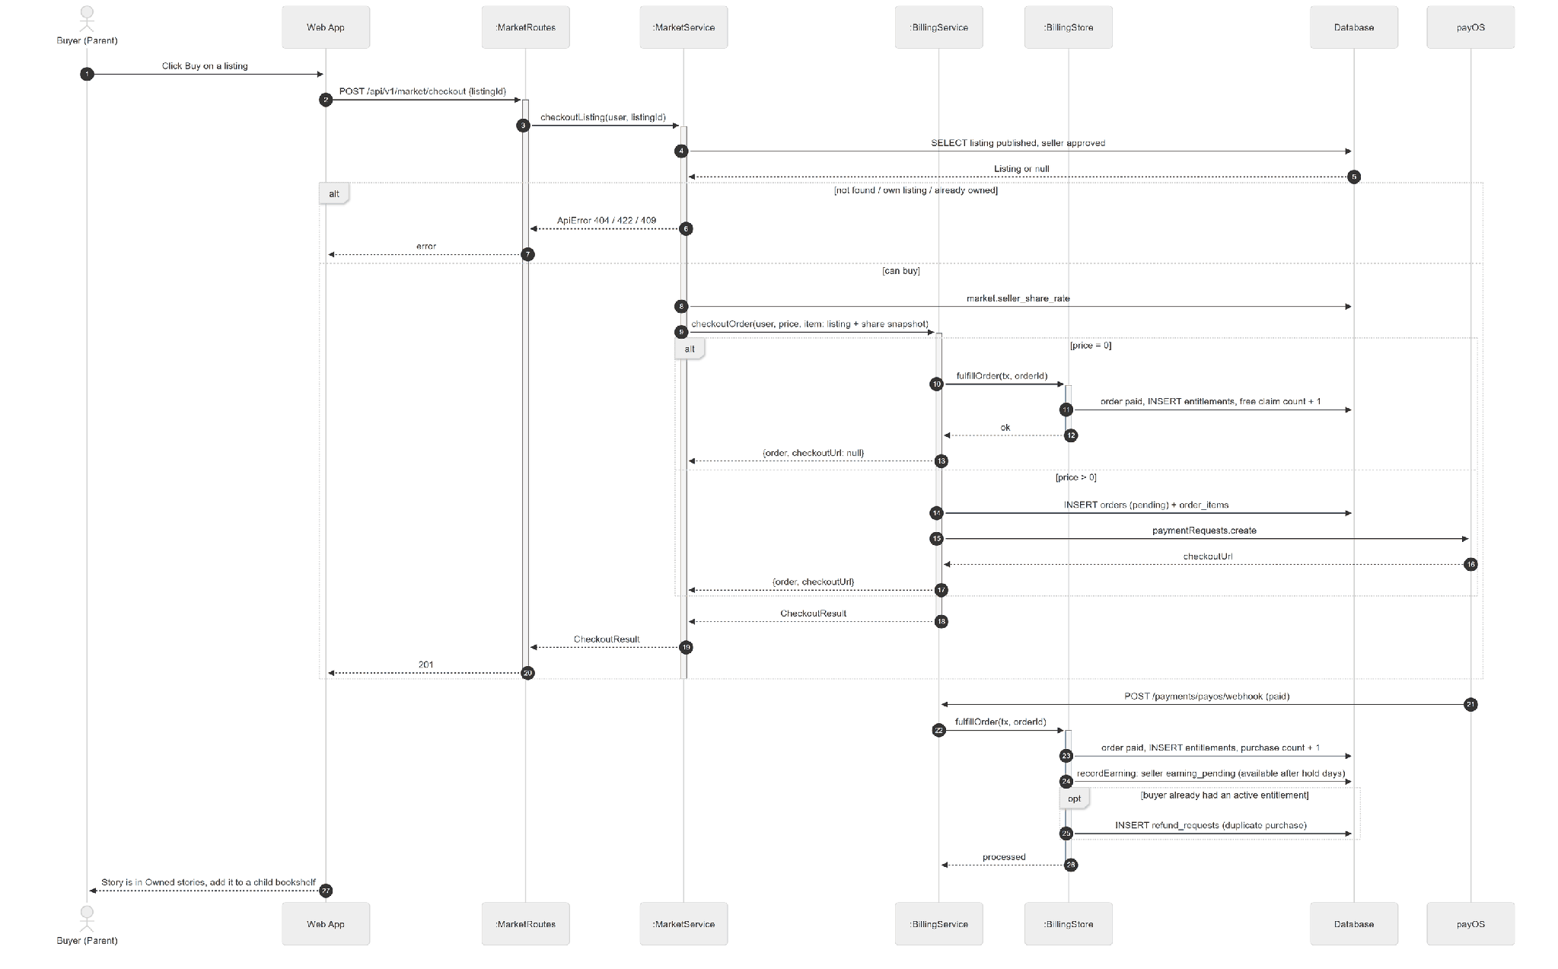

3.8.3 Sequence Diagram - Release Due Earnings
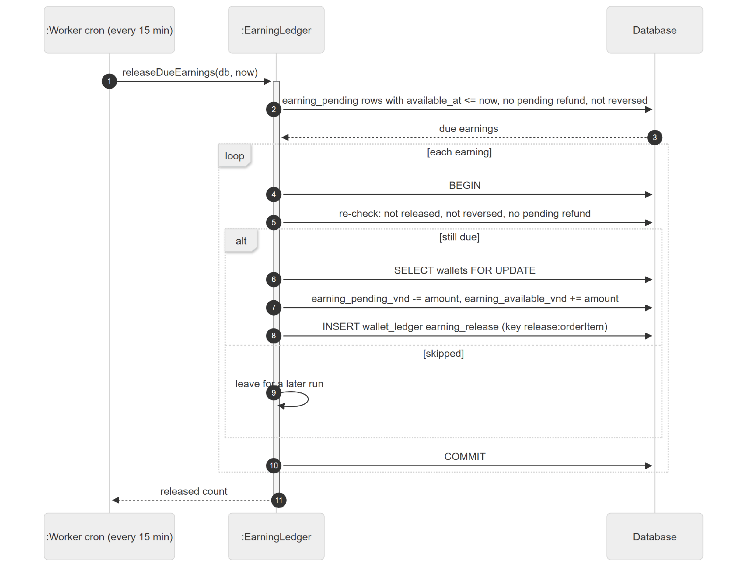

3.8.4 State Diagram
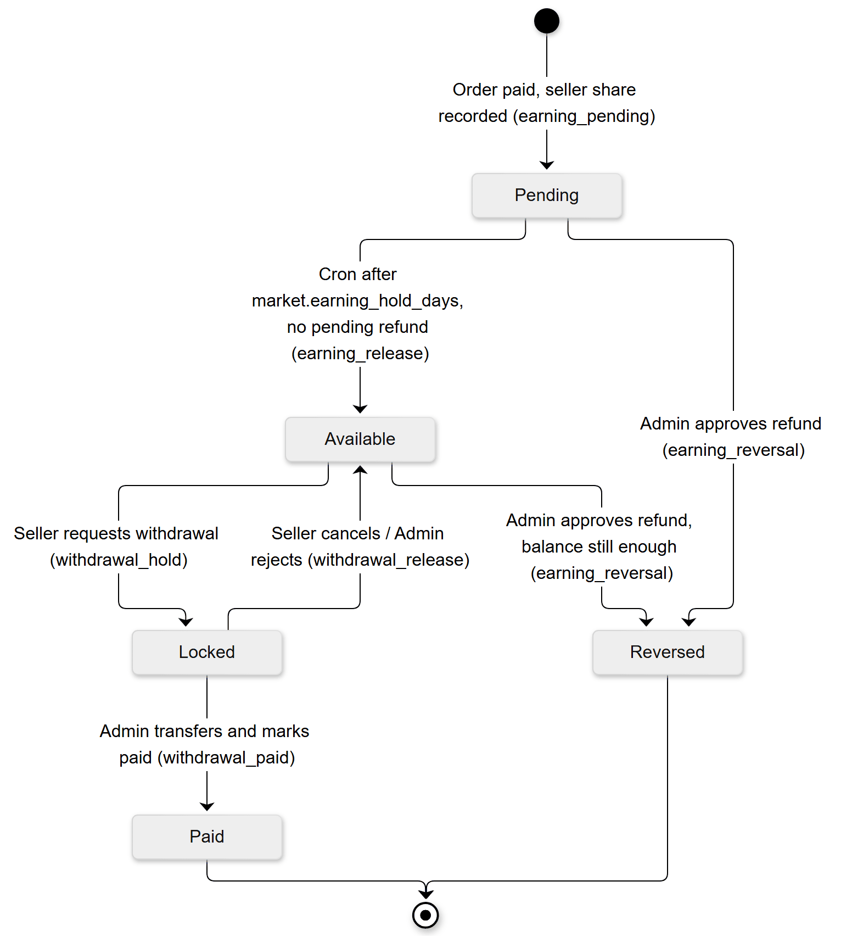

3.9 Seller Withdrawal

3.9.1 Class Diagram
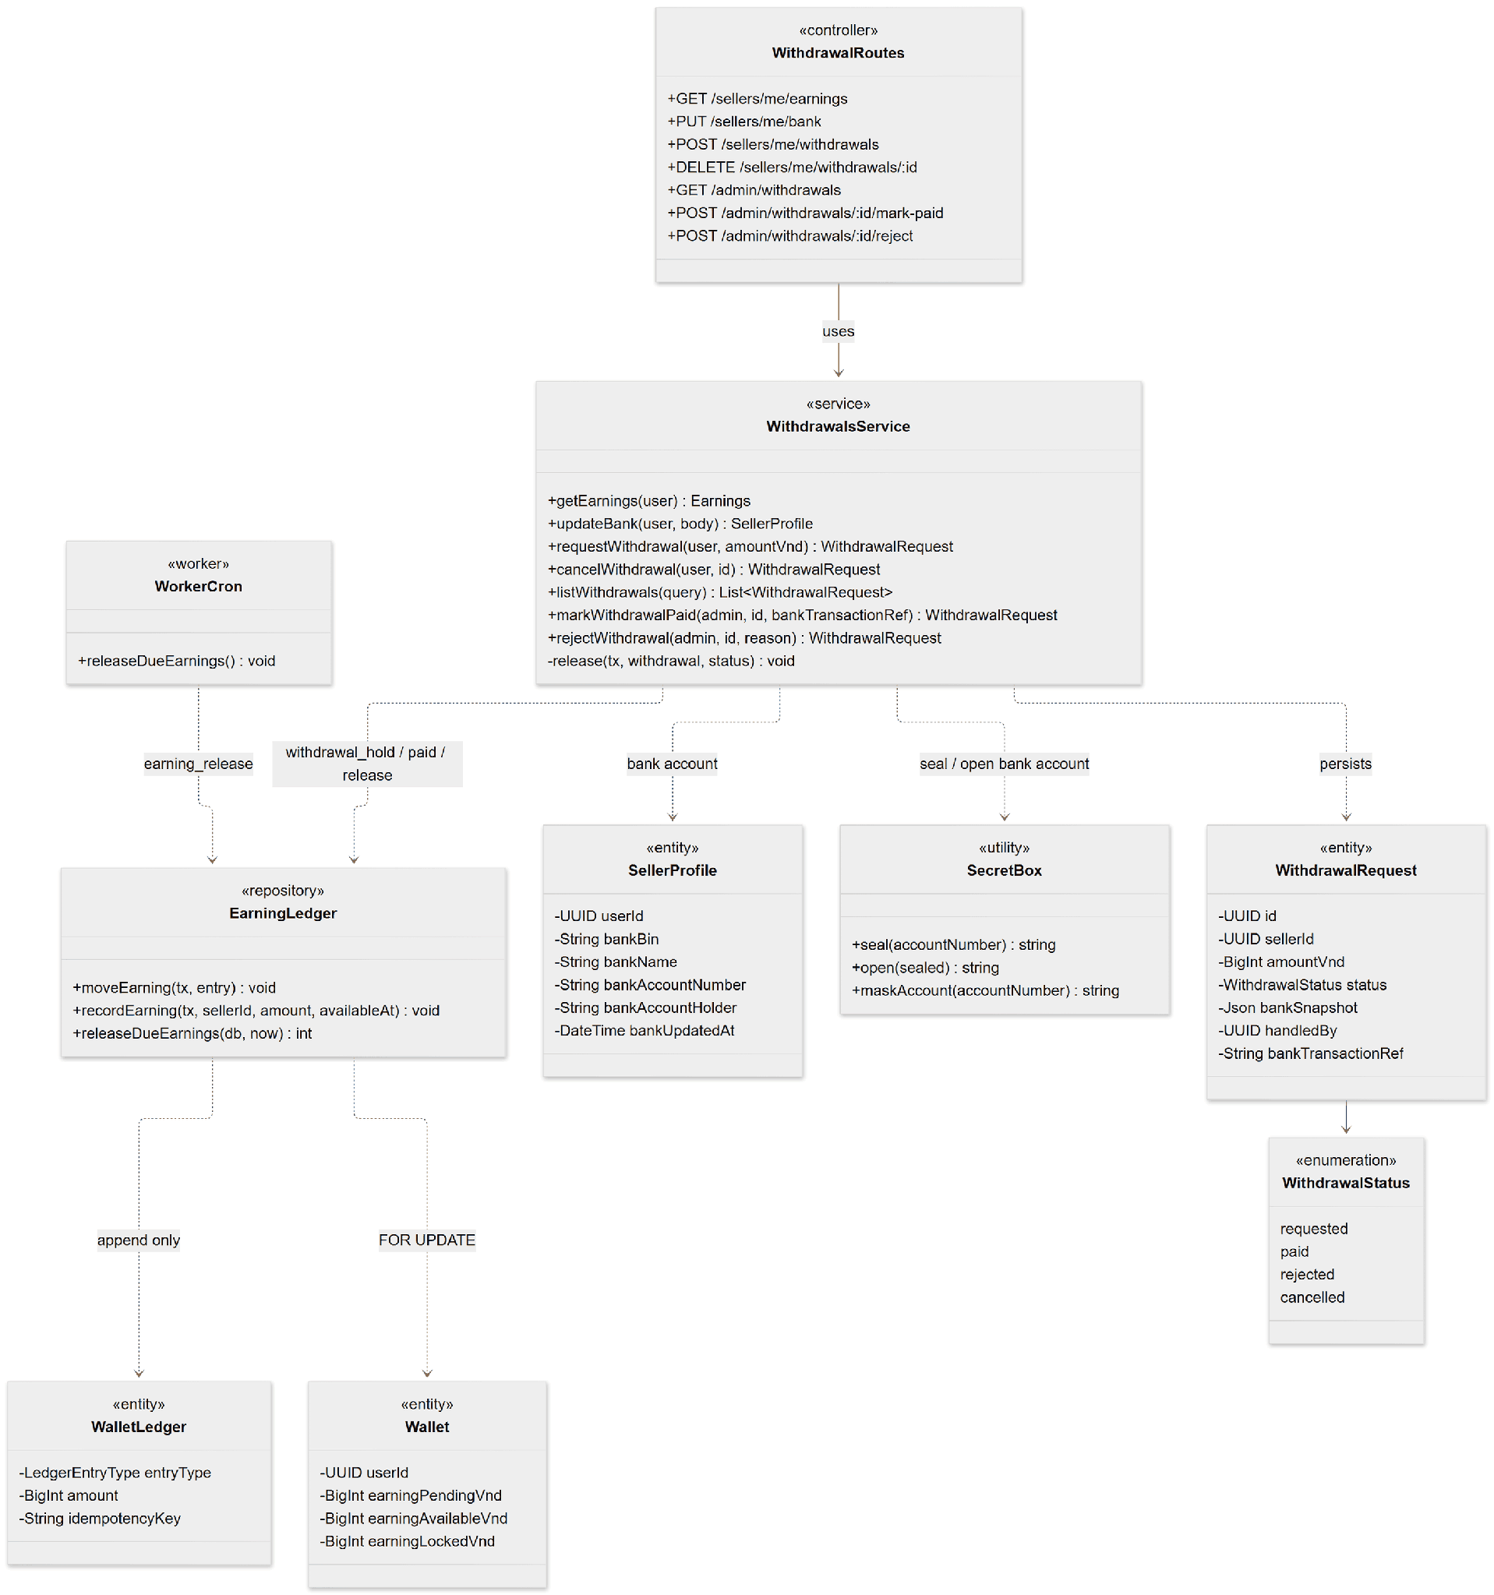

3.9.2 Sequence Diagram - Request and Pay Withdrawal
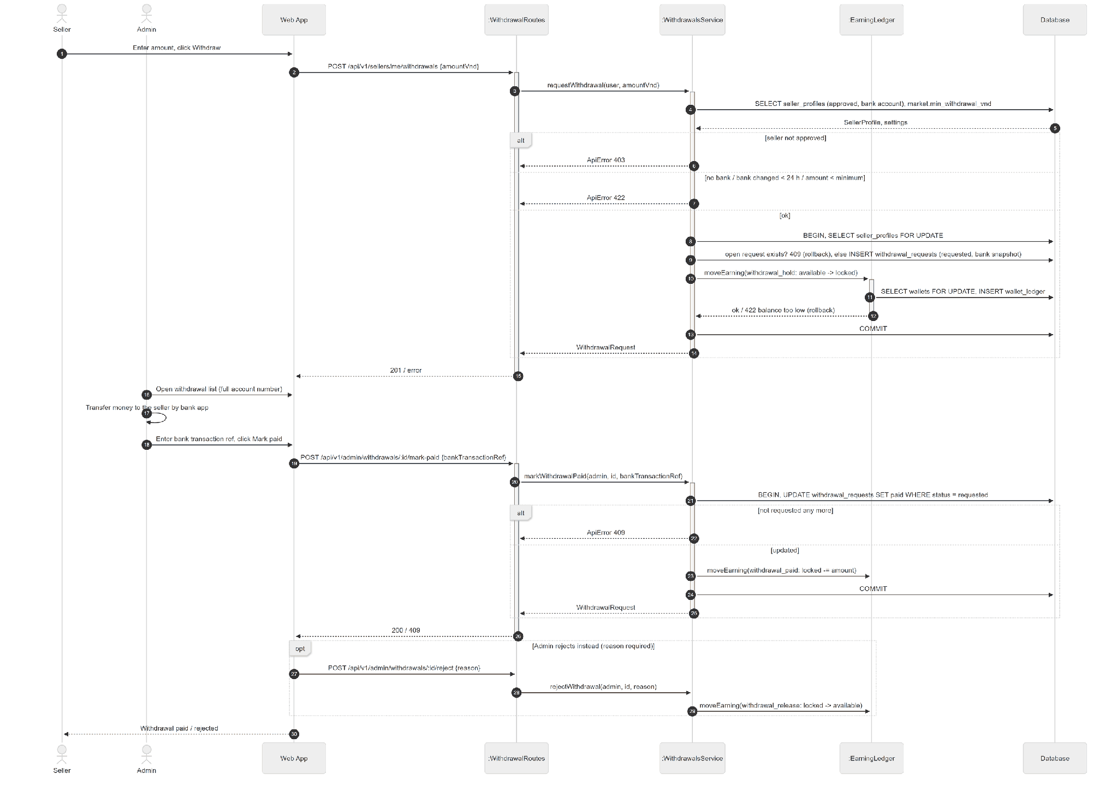

3.9.3 State Diagram
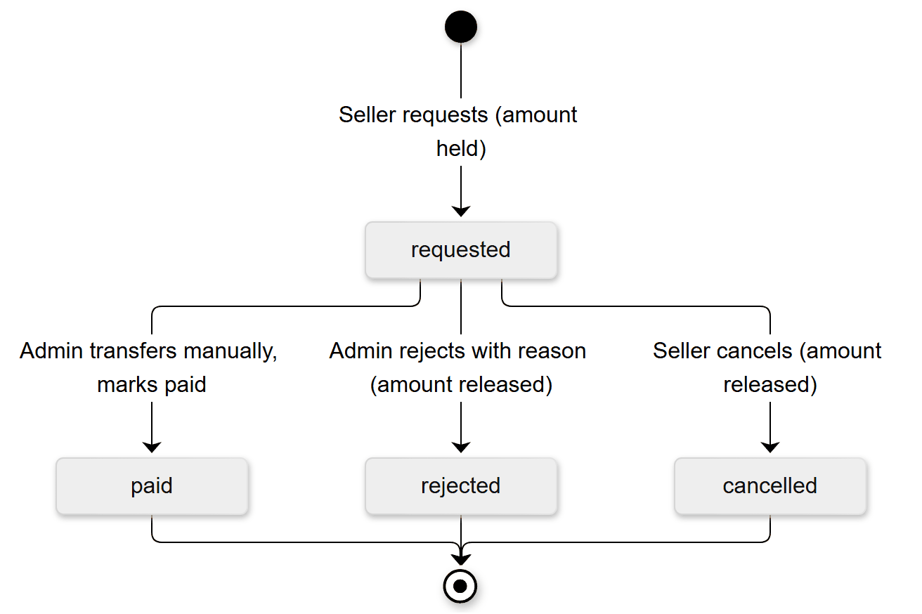

3.10 Kid Mode Reading & EQ Scoring

3.10.1 Class Diagram
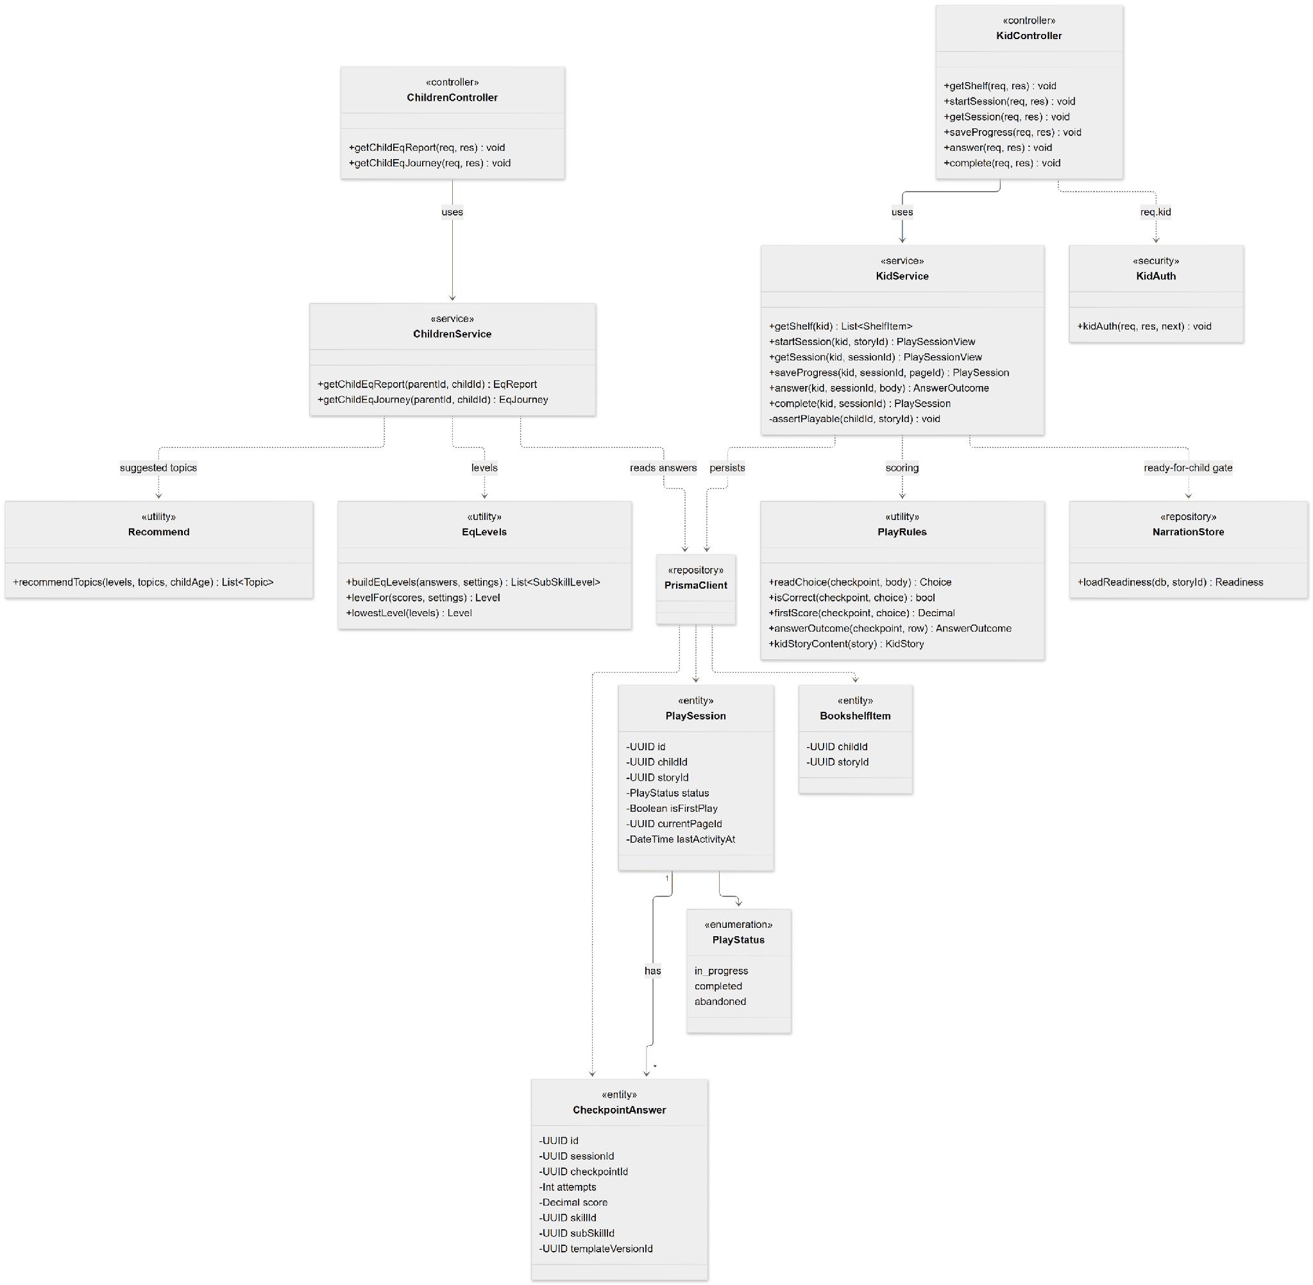

3.10.2 Sequence Diagram - Read Story & Answer Checkpoints
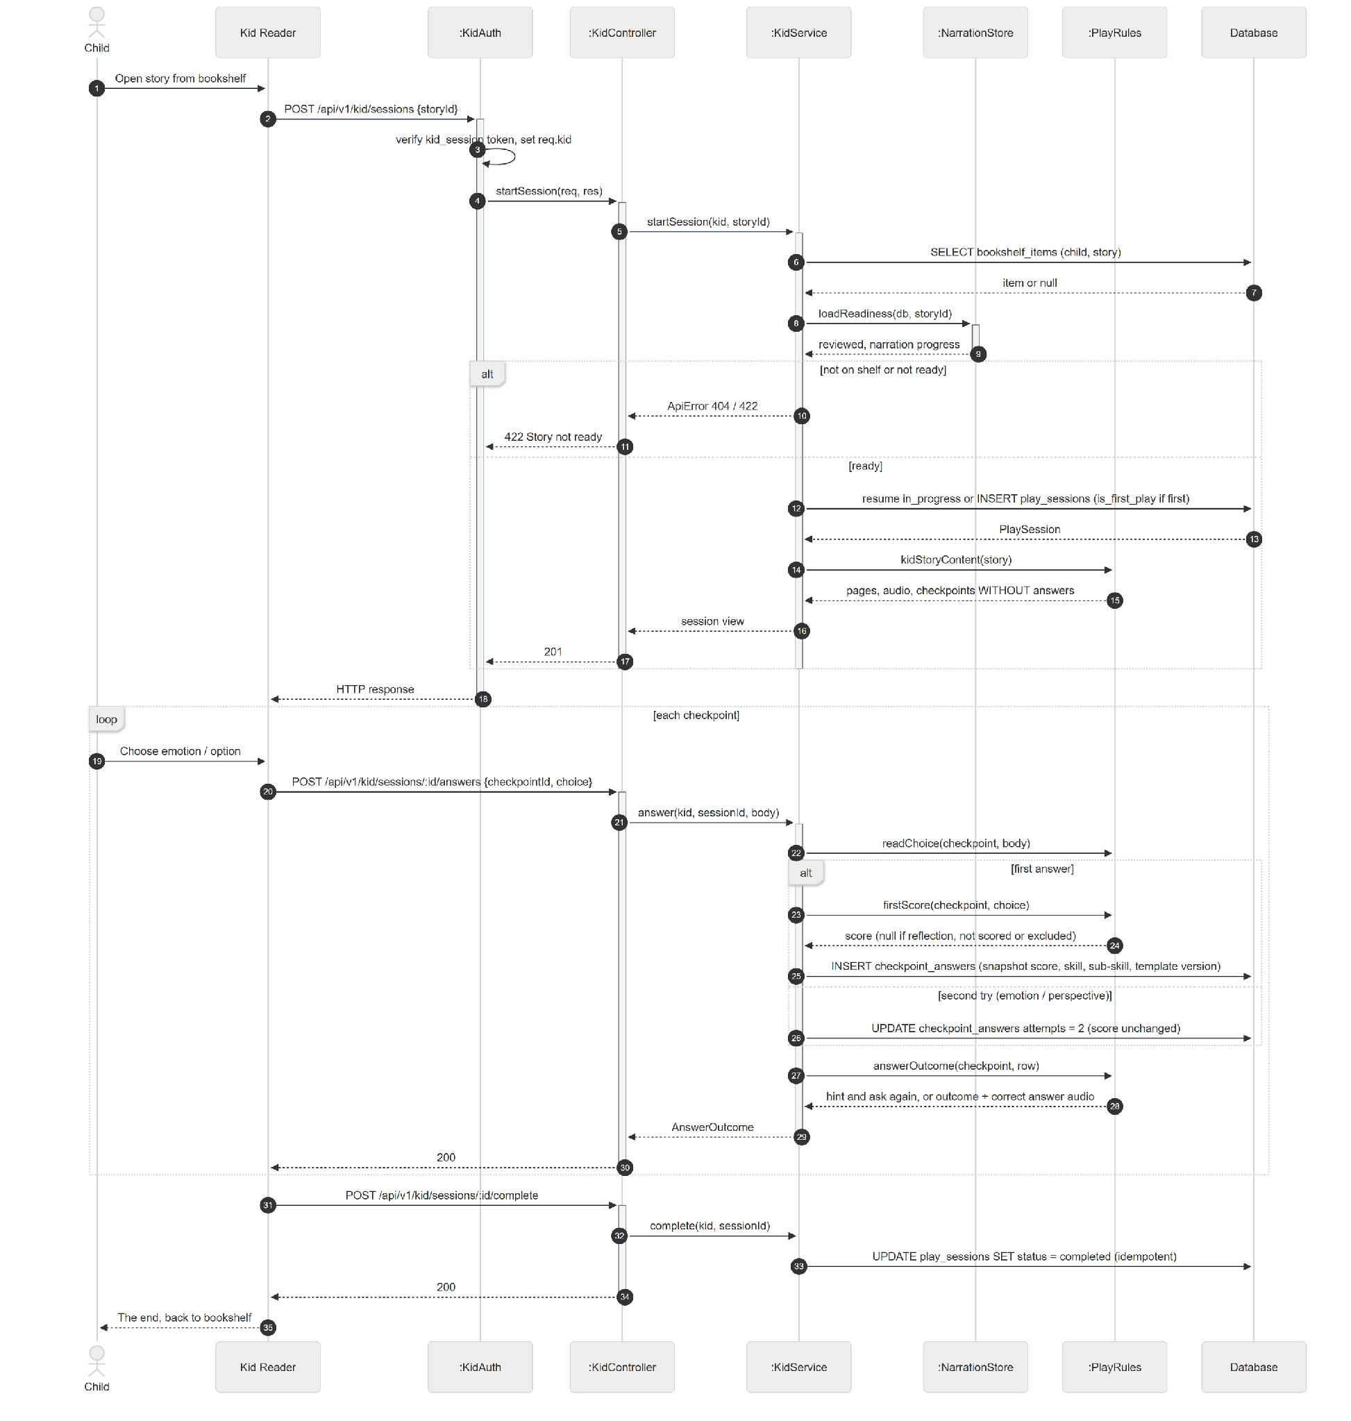

3.10.3 Sequence Diagram - View EQ Report
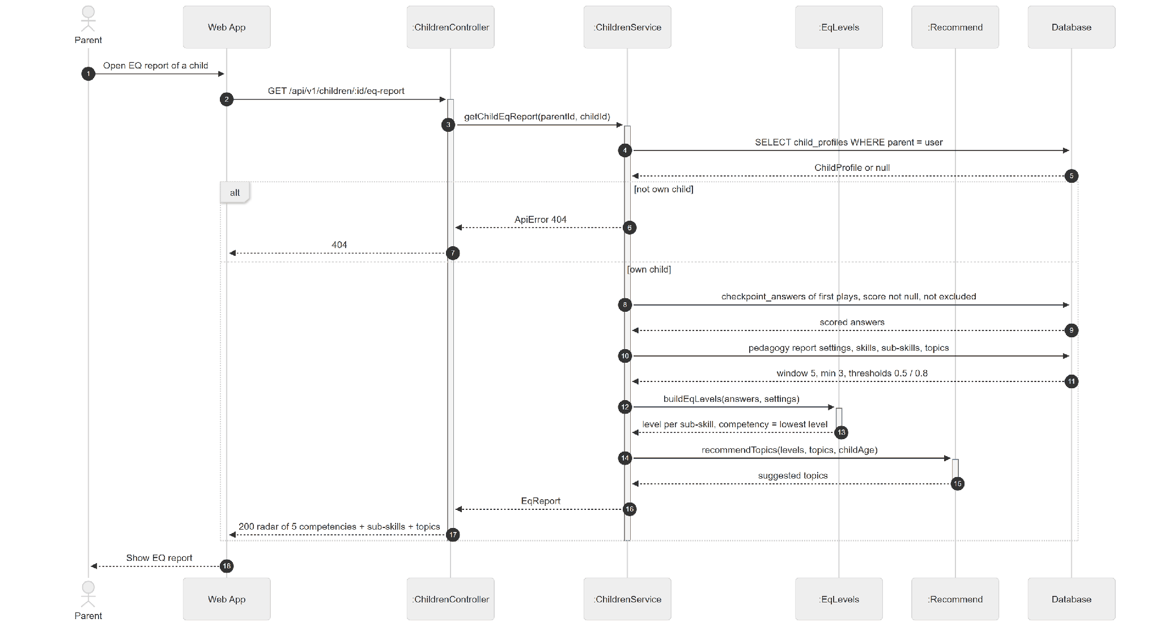

3.10.4 State Diagram

3.11 Pedagogical Library & Question Templates

3.11.1 Class Diagram
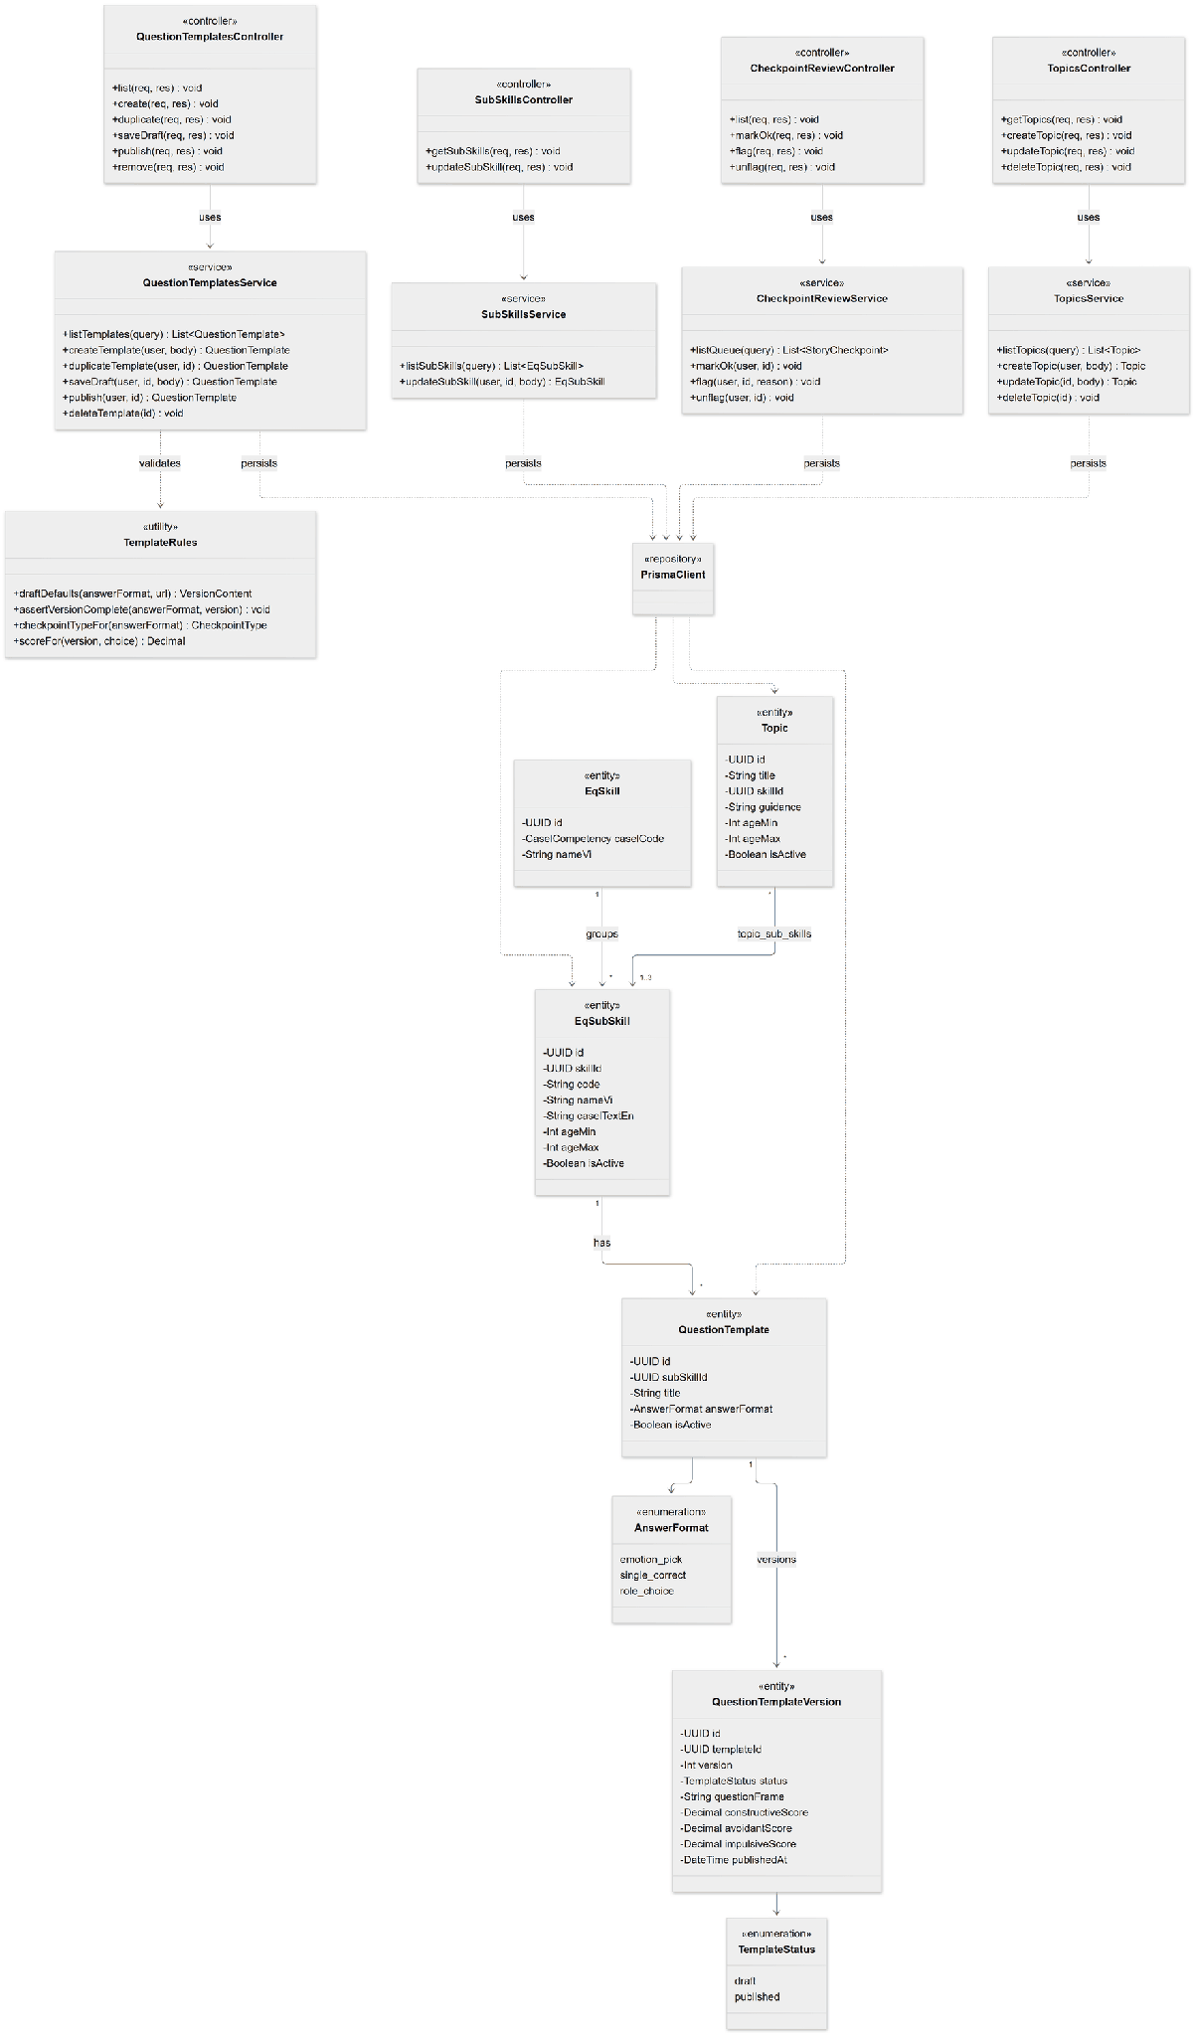

3.11.2 Sequence Diagram - Publish Question Template
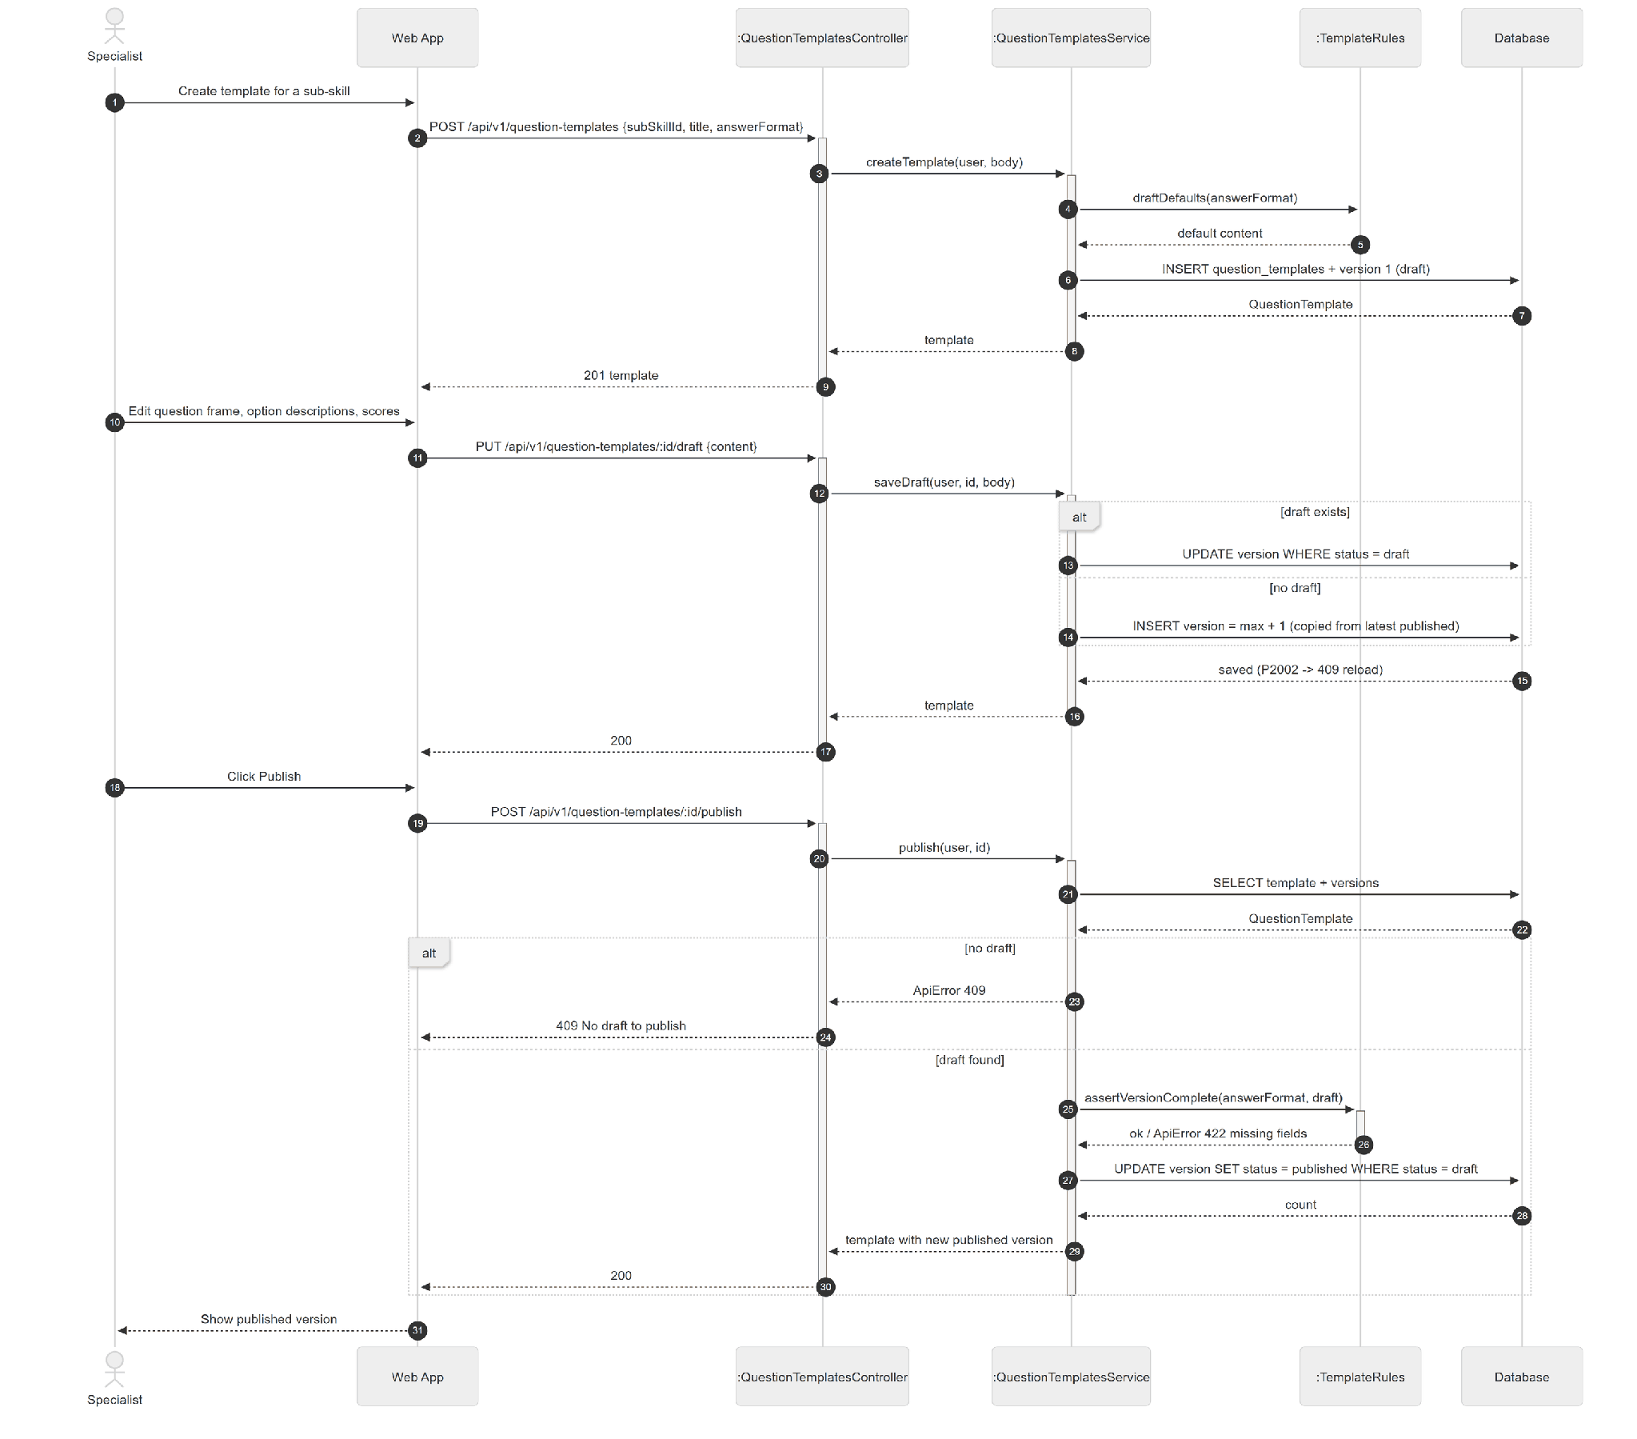

3.11.3 State Diagram

3.12 Platform Monitoring

3.12.1 Class Diagram
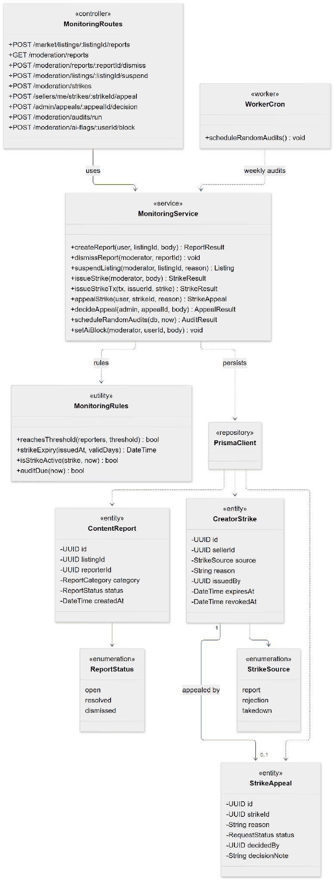

3.12.2 Sequence Diagram - Report and Auto-suspension
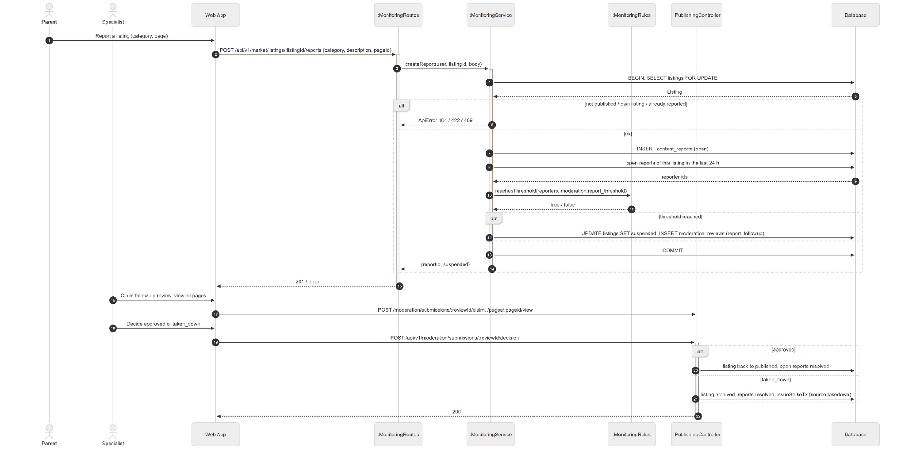

3.12.3 Sequence Diagram - Strike Appeal
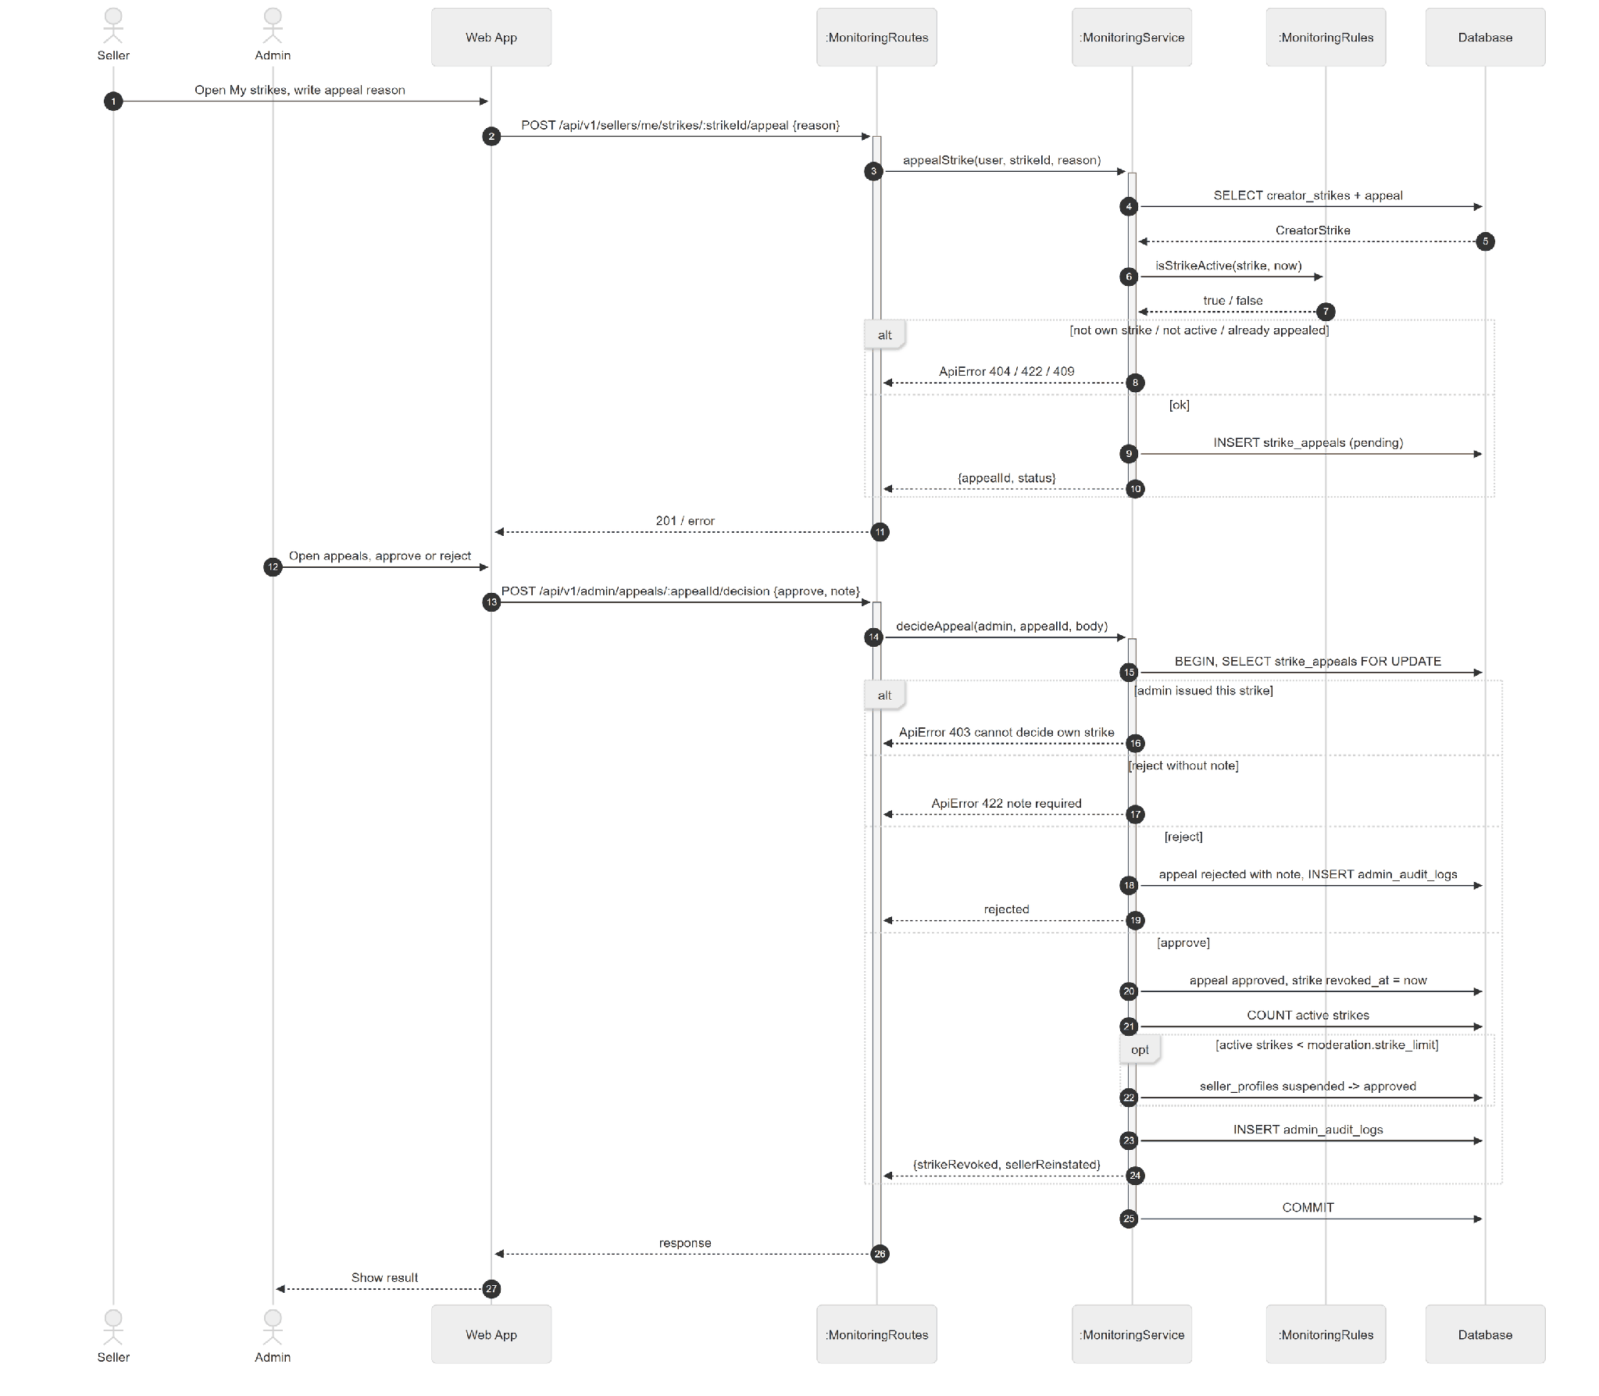

3.12.4 State Diagram
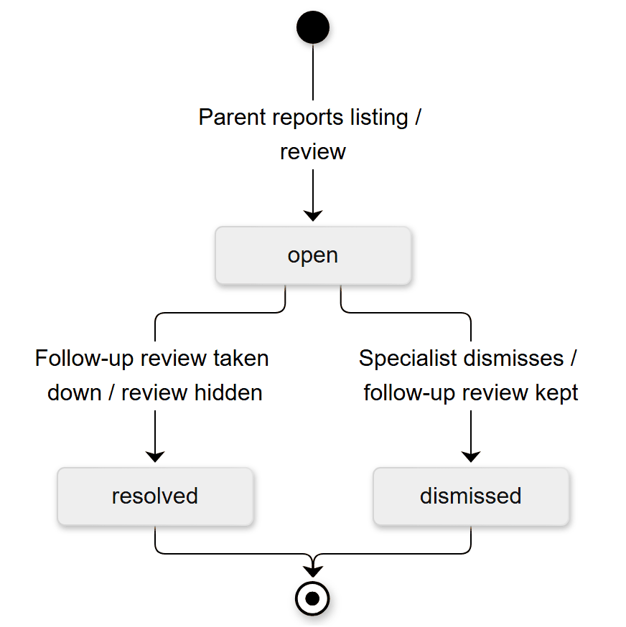
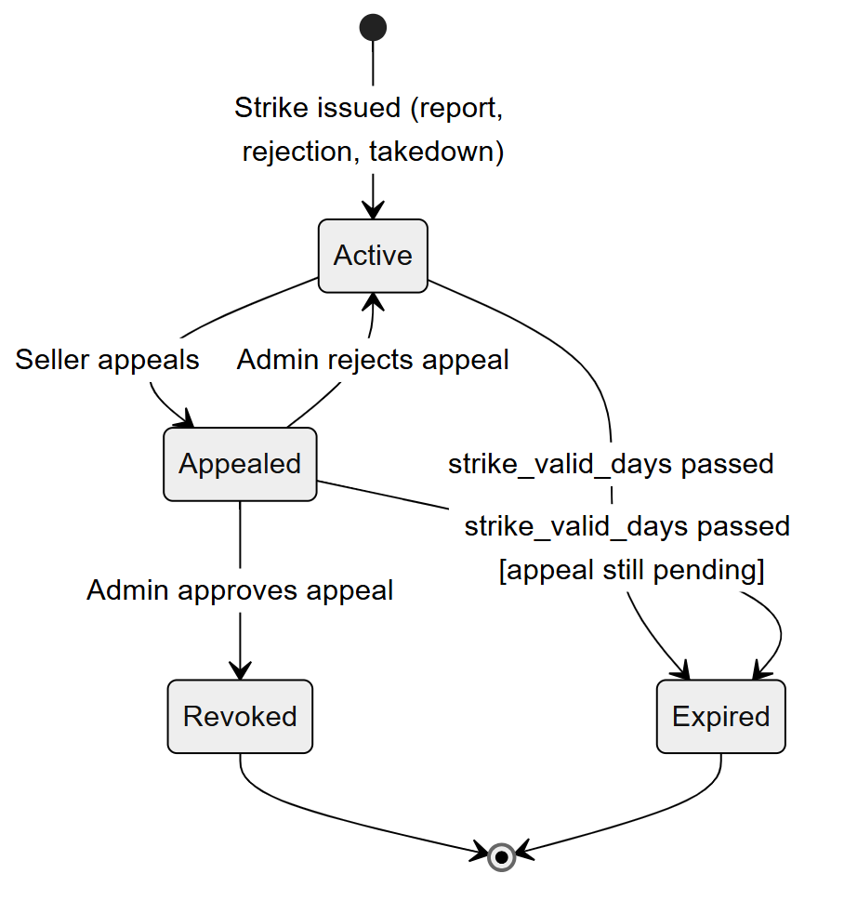

3.13 Refund

3.13.1 Class Diagram
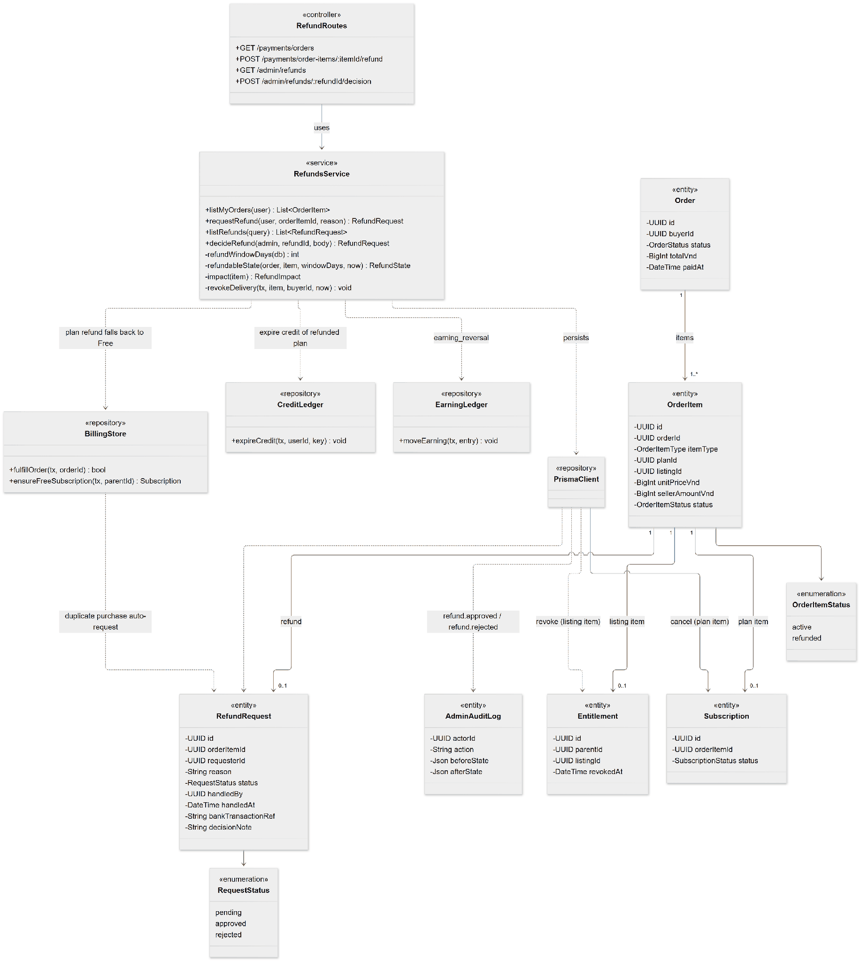

3.13.2 Sequence Diagram - Request and Decide Refund
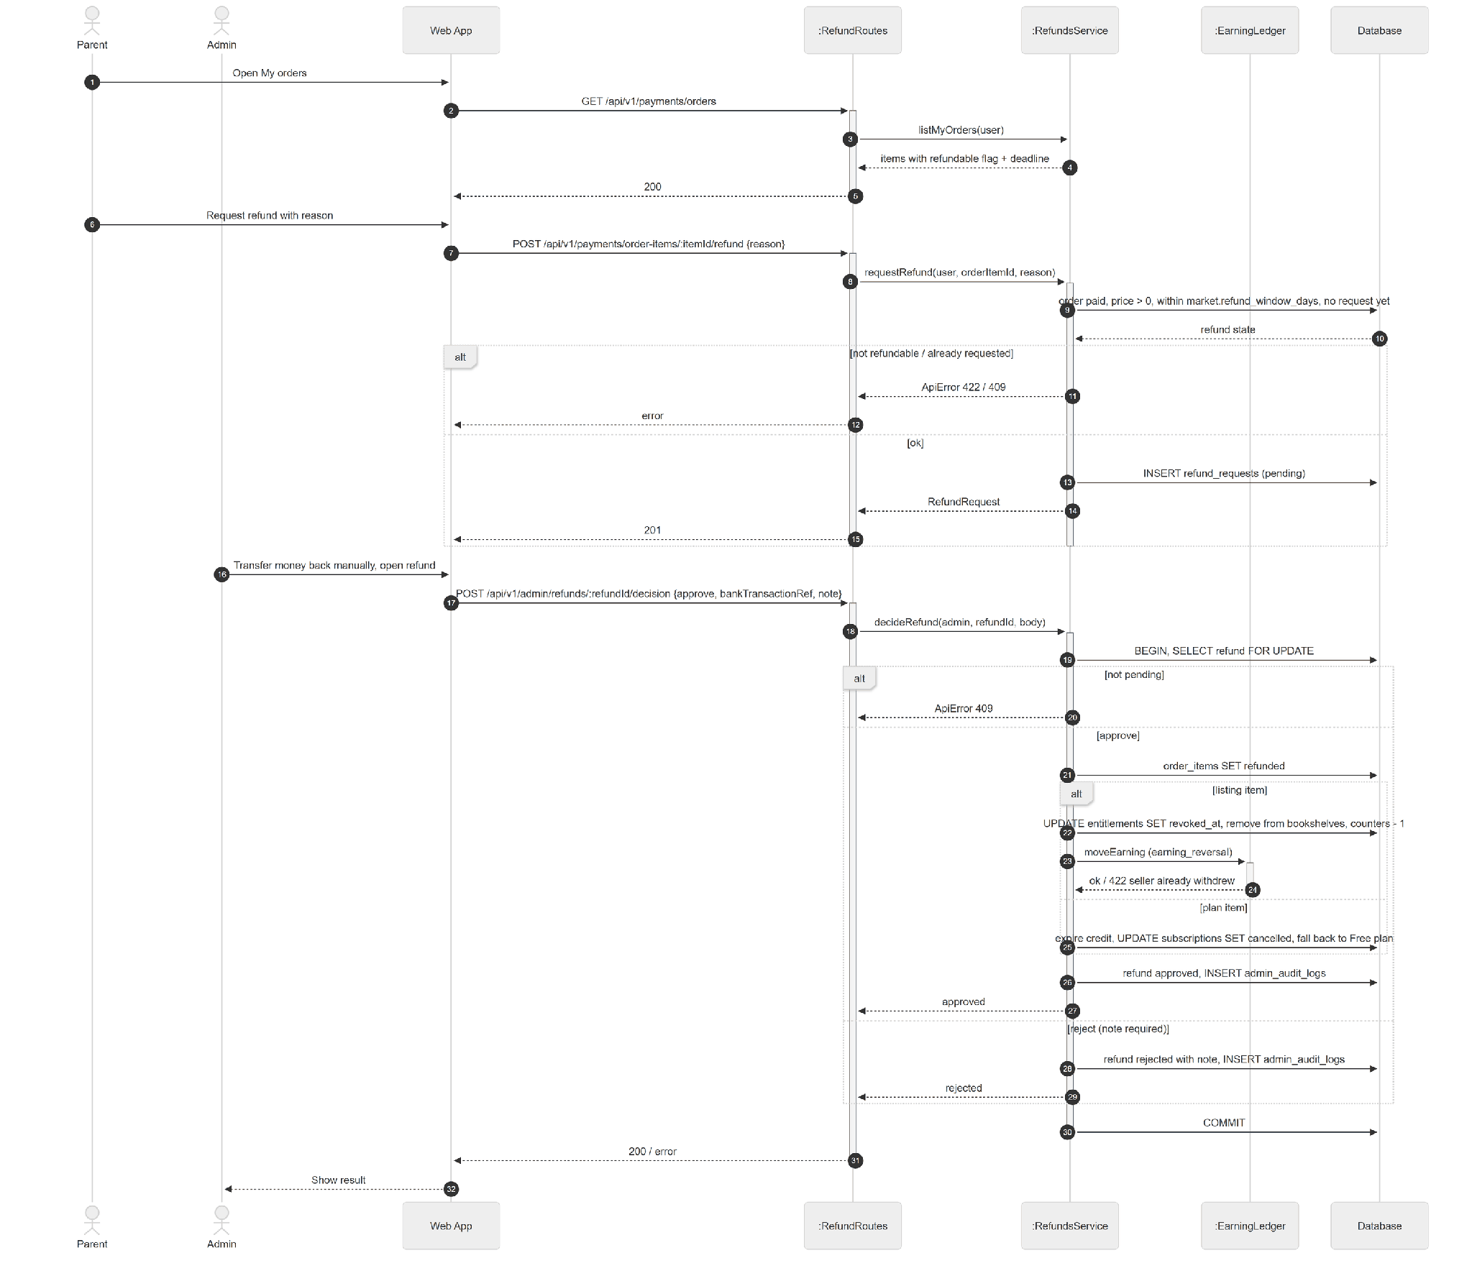

3.13.3 State Diagram

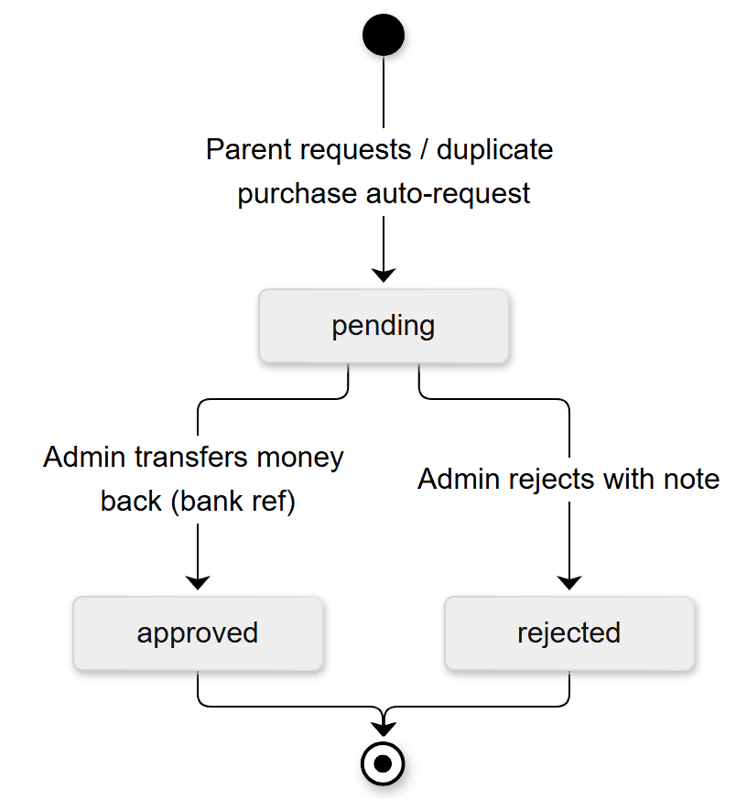

3.14 Kid Mode Session

3.14.1 Class Diagram
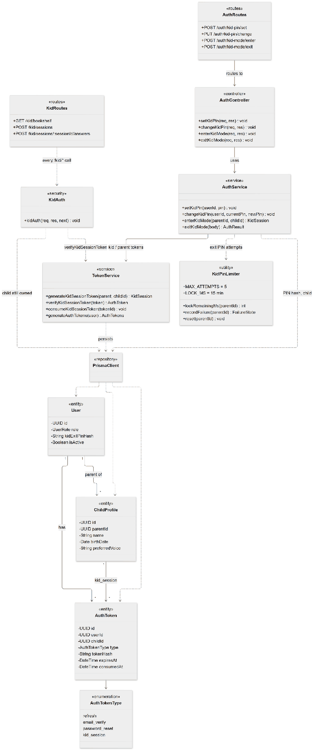

3.14.2 Sequence Diagram - Enter and Exit Kid Mode
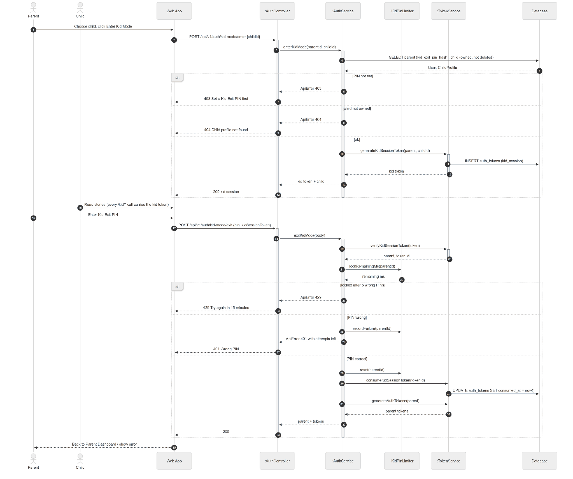

3.14.3 State Diagram
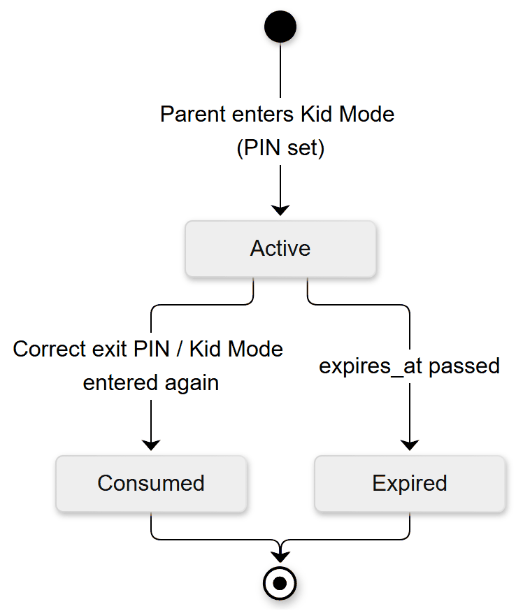

4. Activity Diagram

4.1 AD-01:
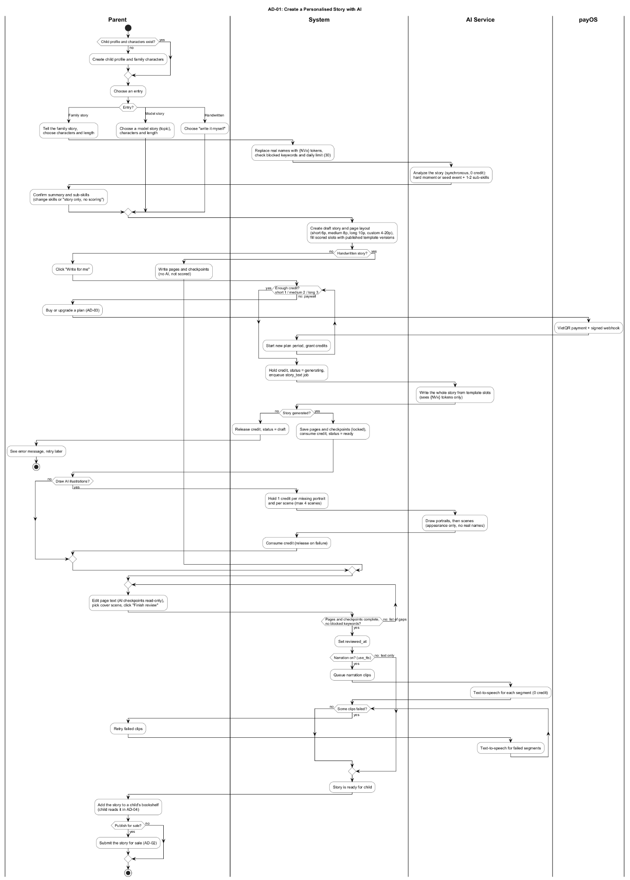

4.2 AD-02:
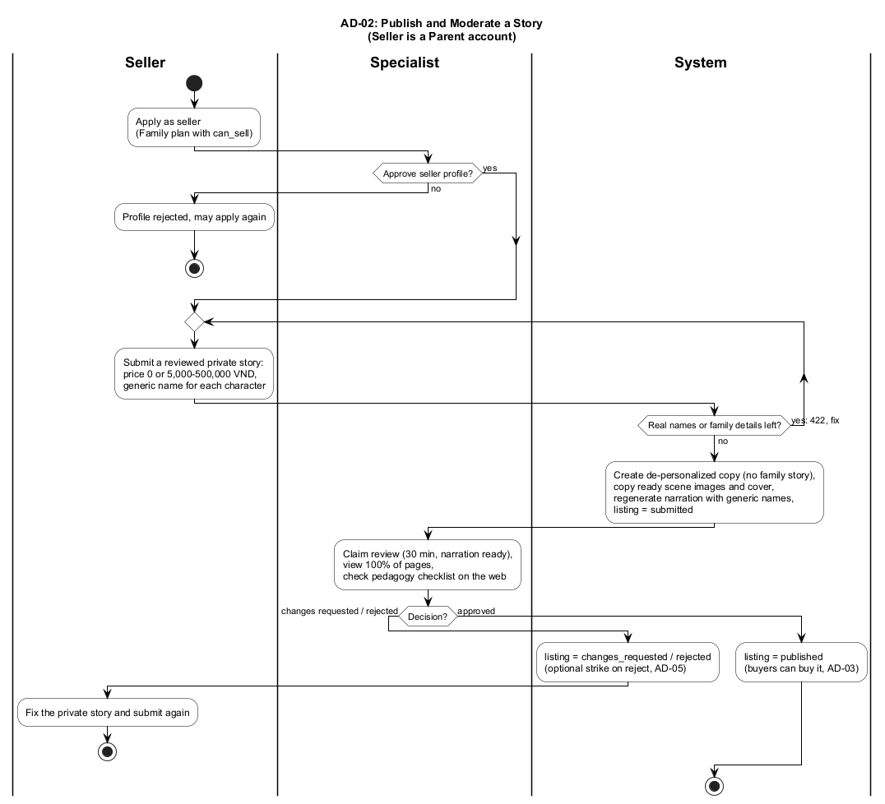

4.3 AD-03:
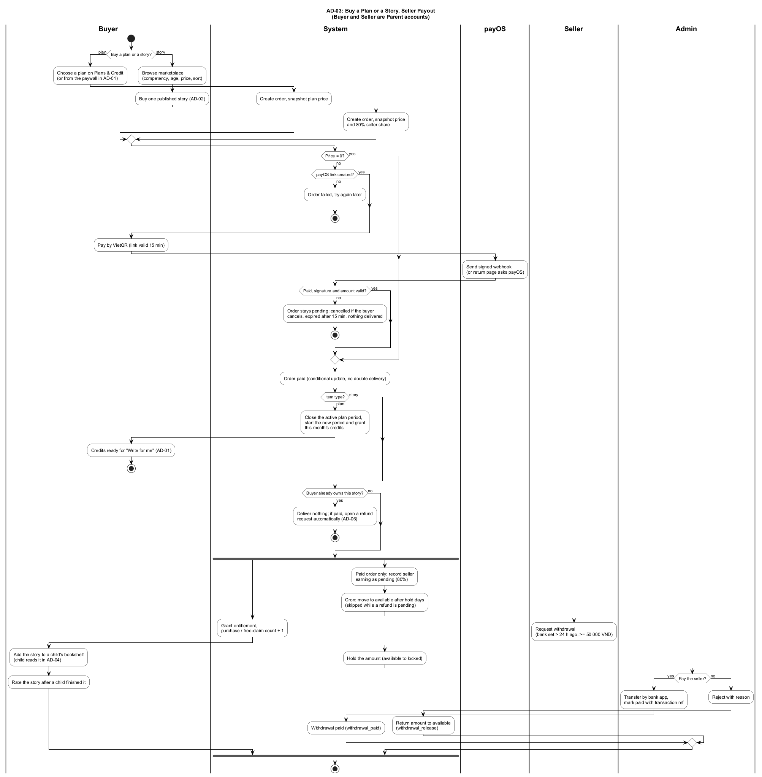

4.4 AD-04:
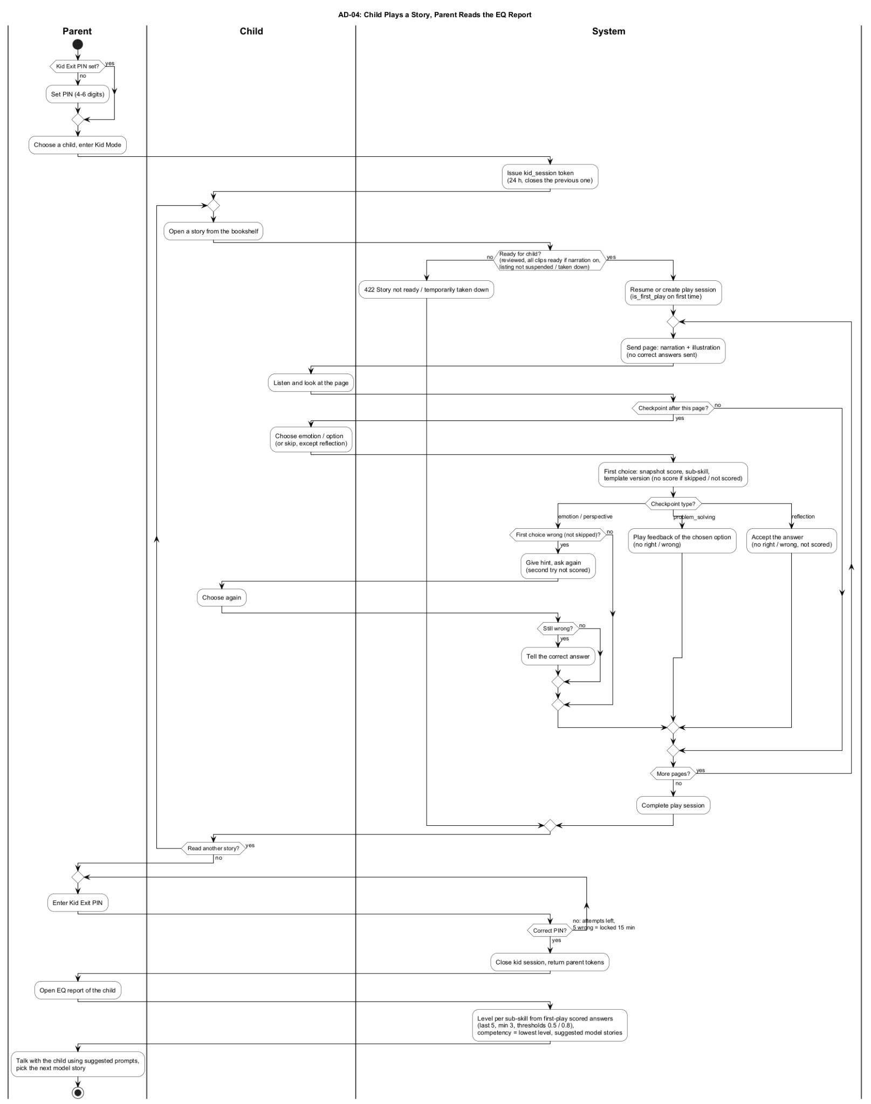

4.5 AD-05:
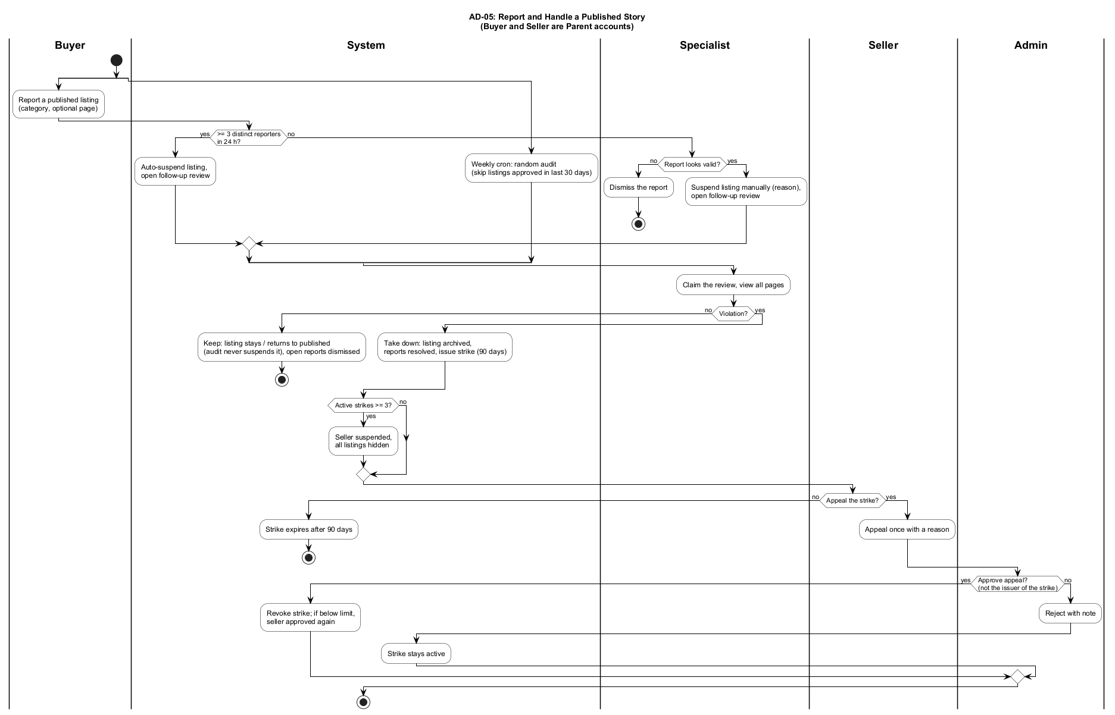

4.6 AD-06:



